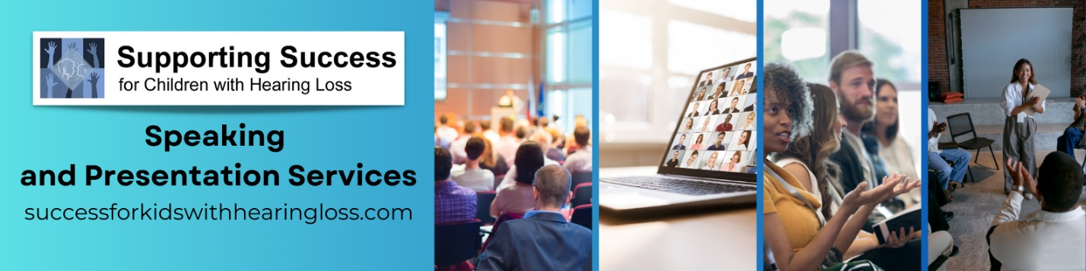
Session information
Session Title | Evaluating Students who are Deaf and Hard of Hearing: Choosing the Appropriate Assessments
Description | Teachers play a critical role in the assessment process for students who are d/Deaf or Hard of Hearing (DHH). Understanding which tools accurately reflect a student’s abilities is essential for developing effective IEPs. This session will review the areas of assessment, determining the appropriate assessment(s) for each area, how and when to use it, and finally interpreting the data to create the most effective IEP possible.
Objectives | - Identify areas of assessment.  - Choose assessment tools and practices that are appropriate for testing those areas.  - Understand how to interpret test results in the context of a student’s hearing difference, language development, and educational background.
Presenter(s) | Brenda Wellen and Michelle Andros
Length | 90 – 120 minutes
Materials

Session Title | Getting Students Ready for Life After High School: Secondary Transition
Description | Preparing d/Deaf and Hard of Hearing students for life beyond high school requires a comprehensive, individualized approach that addresses academic, vocational, social, and self-advocacy skills. This workshop explores best practices in secondary transition planning, including how to develop effective IEP transition goals, facilitate student-centered planning, and connect families and students with resources that support postsecondary success.
Objectives | - Understand the legal framework and key components of secondary transition planning for students who are Deaf or Hard of Hearing.  - Develop individualized and realistic transition goals that reflect each student’s strengths, preferences, interests, and needs.  - Integrate self-advocacy, communication planning, and career readiness skills into daily instruction and IEP development for DHH students.
Presenter(s) | Michelle Andros and/or Brenda Wellen
Length | 90 – 120 minutes
Materials

Session Title | Incorporating the Expanded Core Curriculum for Deaf and Hard of Hearing Students into Daily Instruction
Description | The Expanded Core curriculum (ECC) addresses the unique learning needs of students who are d/Deaf and Hard of Hearing beyond the classroom curriculum. This course gives teachers practical strategies to integrate ECC components – such as self-advocacy, communication, social-emotional skills, and career readiness – into everyday instruction.
Objectives | - Explain the components of the Expanded Core Curriculum and their importance in supporting the holistic development of DHH students.  - Design instructional activities that integrate ECC skills into academic content and individualized student goals.  - Implement daily teaching practices that foster independence, self-advocacy, and social-emotional growth in students who are DHH.
Presenter(s) | Michelle Andros and/or Brenda Wellen
Length | 90 – 120 minutes
Materials

Session Title | Building Skills for Success in the Fast-Paced Classroom
Description | The one-day workshop reviews the information contained within the 500-page Building Skills for Success in the Fast-Paced Classroom book, by Dr. Karen Anderson. This book is owned by more than ¼ of the teachers of the d/Deaf and Hard of Hearing in the U.S. Seven chapters cover assessment, understanding the effects of hearing differences on speech perception, auditory development, social and conversational competence, communication repair, self-concept development, self-advocacy, and accessing the general education curriculum.
Objectives | - Describe the educational impacts of a hearing difference and functional assessment of adverse educational needs.  - Use materials to improve communication skills, including auditory development, social skills, conversational competence.  - Use materials to improve function in the classroom via self-advocacy, communication repair, and accessing the general education curriculum.
Presenter(s) | Brenda Wellen and Michelle Andros
Length | Full day
Materials | Building Skills for Success in the Fast-Paced Classroom book

The Supporting Success Team welcomes opportunities to speak to teachers and other professionals who work with students who are d/Deaf or Hard of Hearing. We also welcome the opportunity to speak to parents and families who need guidance on finding resources and advocating for their child. With years of experience and hands-on knowledge, our team brings valuable insights to educators, administrators, and families. Please note that presentations can be tailored to the audience.
Booking Information:
Notice: Minimum of 60 days’ notice requested.
Format: Virtual or in-person sessions welcomed.
Fees: Based on event details.
Materials: Downloadable resources are provided with each session. Books can be purchased separately.
Contact: Brenda Wellen at brenda@success4kidswhl.com, or call 1-888-963-8991 x4.

