**Bridging Literacy Models: Comparing Scarborough’s Reading Rope and the Deaf Reading Rope**

Reading is a multifaceted process, and various models have been developed to elucidate the components that contribute to skilled reading. Scarborough’s Reading Rope has long been a prominent model for illustrating the main components of literacy that must be woven together to become a skilled reader. The integration of **word recognition** and **language comprehension helps to facilitate the skills necessary for reading skill development. Access** to **language** and **sound** plays an **integral** part to traditional learning in this model. How then, do teachers address phonological awareness and sound based components of the reading rope, when there is little to no sound access? The Deaf Reading Rope, introduced [by Nathan E. Harrison in 2023,](https://www.wnyliteracycollaborative.org/what-is-the-science-of-reading/scarboroughs-reading-rope?utm_source=chatgpt.com) intertwines strands of Scarborough’s reading rope with a new representation of the integration of sub-skills necessary for proficient reading, that caters to different linguistic and sensory experiences.

### **Scarborough’s Reading Rope: A Foundation for Understanding Reading Development**

Developed by Dr. Hollis Scarborough in 2001, [Scarborough’s Reading Rope](https://www.reallygreatreading.com/blog/scarboroughs-reading-rope?srsltid=AfmBOopERInAo8NEJ47lL6Ct2XF35ztUgAaTwAy3j_-Uho--ehQiuEjw&utm_source=chatgpt.com) illustrates how skilled reading is the result of intertwined language comprehension and word recognition skills. The model comprises two main strands:

**Language Comprehension: This** [**upper strand**](https://www.wnyliteracycollaborative.org/what-is-the-science-of-reading/scarboroughs-reading-rope?utm_source=chatgpt.com) **includes background knowledge, vocabulary, language structures, verbal reasoning, and literacy knowledge**.

**Word Recognition:** **The** [**lower strand**](https://dyslexiaida.org/scarboroughs-reading-rope-a-groundbreaking-infographic/?utm_source=chatgpt.com) **encompasses phonological awareness, decoding, and sight recognition of familiar words**.

As these strands become increasingly automatic and strategic through instruction and practice, they weave together to produce fluent and skilled reading .

### **The Deaf Reading Rope: Tailoring Literacy Models for Deaf and Hard of Hearing Learners**

Recognizing that traditional reading models may not fully address the variety of experiences for deaf and hard of hearing (DHH) learners, Nathan E. Harrison introduced the Deaf Reading Rope in 2023. This model adapts the original framework to better represent the bilingual and bimodal nature of DHH students' language acquisition, particularly those who use American Sign Language (ASL) and English.

The [Deaf Reading Rope](https://osf.io/d96jx/) consists of three primary strands:

**ASL Language Comprehension**: Acknowledging ASL as a complete and natural language, this strand emphasizes the importance of ASL proficiency in developing reading skills.

1. **English Language Comprehension**: This strand focuses on the understanding of English, which may be acquired through reading and writing, especially for students who primarily use ASL.
2. **Word Recognition**: Similar to Scarborough’s model, this strand includes decoding and sight recognition but is adapted to consider the visual nature of ASL and the different pathways DHH students may use to recognize written words

By integrating these strands, the Deaf Reading Rope provides a more inclusive framework that reflects the linguistic realities of DHH learners.

### **Comparative Analysis: Aligning and Differentiating the Models**

While both models aim to dissect the components of skilled reading, their applications differ based on the target populations:

**Language Modalities**: Scarborough’s model is primarily designed for learners acquiring reading skills through spoken language, whereas the Deaf Reading Rope incorporates both signed and written languages, acknowledging the bilingual nature of DHH learners.

* **Instructional Implications**: Educators using Scarborough’s model may focus on phonological awareness and decoding strategies suited for hearing students. In contrast, the Deaf Reading Rope suggests instructional strategies that leverage ASL proficiency to support English literacy, such as using ASL storytelling to build background knowledge and vocabulary.
* **Cultural and Linguistic Recognition**: The Deaf Reading Rope explicitly recognizes ASL as a foundational language, promoting a culturally responsive approach to literacy that validates the linguistic identity of DHH students.

### **Visual Representations**

Visual aids are integral to both models, providing educators with clear frameworks for instruction.

* **Deaf Reading Rope**: Often illustrated with distinct strands for ASL and English language comprehension, along with word recognition, emphasizing the bilingual and bimodal aspects of DHH literacy development.
* **Scarborough’s Reading Rope**: Typically depicted as a rope with intertwining strands representing the various components of language comprehension and word recognition.

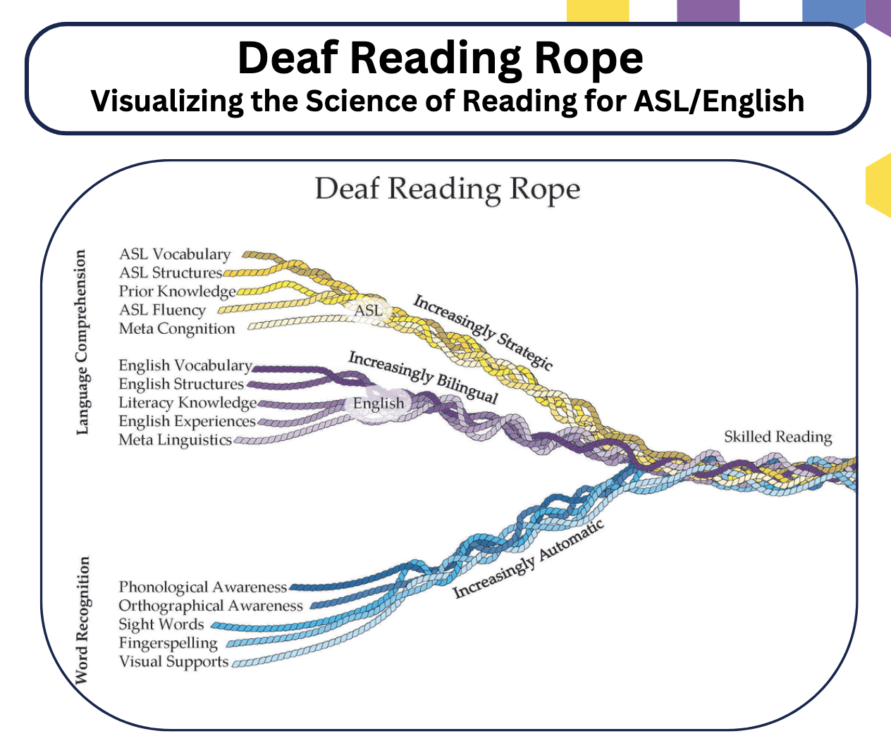

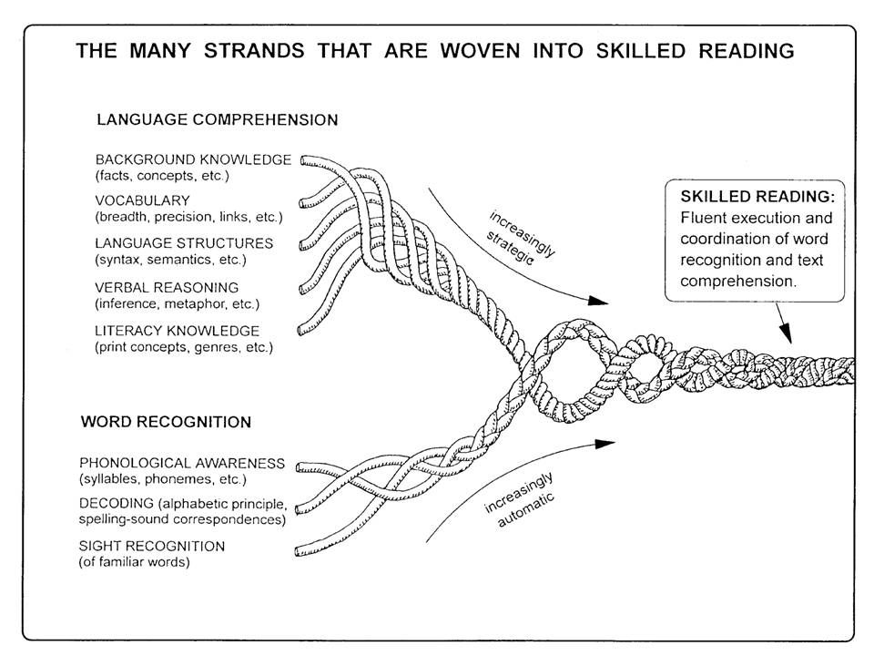

### 

Understanding and applying appropriate **literacy models is crucial for effective reading instruction**. While Scarborough’s Reading Rope offers a comprehensive framework for hearing learners, the Deaf Reading Rope extends this model to accommodate the unique linguistic experiences of DHH students. Educators should consider these differences to provide inclusive and effective literacy instruction that respects and builds upon each learner's language background.

***References****:*

* Scarborough, H. S. (2001). Connecting early language and literacy to later reading (dis)abilities: Evidence, theory, and practice. In S. B. Neuman & D. K. Dickinson (Eds.), *Handbook of Early Literacy Research* (pp. 97–110). Guilford Press. [Landmark Outreach](https://www.landmarkoutreach.org/strategies/scarboroughs-reading-rope/?utm_source=chatgpt.com)
* Harrison, N. E. (2023). Deaf Reading Rope: Visualizing the Science of Reading for ASL/English. Retrieved from <https://osf.io/d96jx>