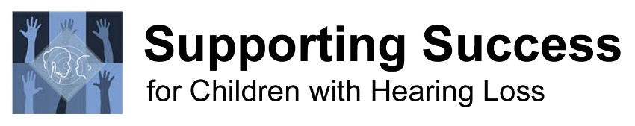
Resources for identifying DHH Student Needs: Eligibility Assessment and Beyond

FUN refers to a FUNCTIONAL Assessment. FUN=Preschool/K FUN=School-Age Checklists, age-anchored hierarchies.
FOR refers to a FORMAL Evaluation. FOR=Preschool/K FOR=School-Age Norm-referenced or criterion-referenced.

Speech Perception
- FUN/FUN ELFLing procedure – precision & functional estimate of listening bubble, Steps to Assessment Age 3-12
- FUN/FUN Iowa Medial Consonant Test precision listening in Teacher Tools Library / Steps to Assessment Age 3-12
- FUN/FUN Impact of Hearing Loss on Listening, Learning, & Social Interaction estimate audibility from audiogram
- FUN/FUN Children’s Home Inventory for Listening Difficulties (CHILD) Age 3-12, parent report of listening function
- FUN Listening Inventory For Education-Revised (LIFE-R) Grade 3+, student appraisal of listening challenges
- FUN Recorded Functional Listening Evaluation Using Sentences (FLE) YouTube video Webcast Performance norms.
Do not use WIPI or NU-CHIPS picture books for children under age 5 to perform single-word FLE assessment.
- FOR/FOR Early Speech Perception Test criterion-referenced for lower functioning/new listeners
- FOR/FOR Speech Perception Instructional Curriculum & Evaluation (SPICE) extensive listening skills assessment
- FOR Auditory Skills Assessment (ASA) Age 3:6 – 6:11. Auditory-related and phonological skills. Presented on CD.
- FOR Developmental Test of Auditory Perception (DTAP) Age 6:0 – 18:11 years. Auditory skills (phonemes, discrimination, etc.) that are language-related, non-language related, in quiet and in noise. Presented on CD.
- FOR Components of Pronunciation for Speech Intelligibility (CPSI) Grade 4+. Pronunciation errors reflect speech perception deficits (pronunciation, not articulation). In Building Success with Intelligible Speech.
Performance Review
- FUN/FUN Observational Record of Behavior of Deaf or Hard of Hearing Students observation checklist; PreK-12
- FUN Preschool Language Pack checklists for vocabulary, symbolic play, pragmatics, grammar/syntax
- FUN/FUN Screening Instruments For Targeting Educational Risk (SIFTERs – Preschool, Elementary, Secondary) fillable versions in Teacher Inservice Combo, Documenting Skills for Success; download and print; PreK-12
- FUN/FUN PARC – Placement & Readiness Checklists preschool/K, school-age, inclusion readiness, etc.
- FUN Starting School LIFE - Listening Inventory For Education-Revised; incorporates CHILD checklist results; PreK-gr 5
- FUN Teacher Listening Inventory For Education-Revised (LIFE-R) Grade 3+; focuses on attention and participation
- FUN Classroom Participation Questionnaire (CPQ) in Building Skills for Success in the Fast-Paced Classroom
Auditory Skills Development
- FUN Listening Skills Develop Early – A Hierarchy of Auditory Skills Learned by Age 4 Years
- FUN/FUN Contrasts for Auditory & Speech Training (CAST) includes screening process for fine auditory discrim.
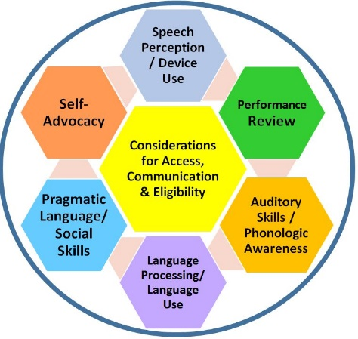
- FOR/FOR Cottage Acquisition Scales for Listening, Language & Speech (CASLLS) Pre-speech-Sentence Level; track development of minute skills across time effectively
- FOR/FOR Speech Perception Instructional Curriculum & Evaluation (SPICE)
extensive listening skills assessment and intervention curriculum
Phonological Awareness
- FUN/FUN Phonological Awareness Chipper Chat assessment to screen each of 12
phonological awareness areas and then target intervention, age 4:0+
- FOR Phonological Awareness Test (PAT-2:NU) Age 5:0-9:11 years; thorough assessment
- FOR/FOR Test of Narrative Language (TNL) Age 4:0-15:11 years, conversation skills
Language Use (other tests can be used to assess receptive/expressive language ability)
- FUN Preschool Language Pack checklists for vocabulary, symbolic play, pragmatics, grammar/syntax (TAGS)
- FOR/FOR Cottage Acquisition Scales for Listening, Language & Speech (CASLLS) Pre-speech-Sentence Level
- FOR/FOR Comprehensive Assessment of Spoken Language (CASL) Age 3:0-21:11; battery of 15 language tests
- FOR/FOR Clinical Evaluation of Language Fundamentals – 5 (CELF-V); Age 5:0-21:11; battery of 16 language tests
- FOR/FOR Test of Auditory Comprehension of Language-4 (TACL-4) Age 3:0-12:11, receptive vocabulary, syntax

Language Processing/Comprehension
- FOR/FOR TAPS-4: Language Processing Skills Assessment Age 5:0-21; memory, phonolog. awarens., comprehension
- FOR Listening Comprehension Test 2 Age 6:0-11:11 years; correlates well with actual classroom function
- FOR Listening Comprehension Test Adolescent Age 12:0-18:0 years; correlates well with actual classroom function
- FOR Assessment of Story Comprehension (ASC) Age 3:0-5:0 years. Early listening comprehension, quick to perform
- FOR/FOR Oral Passage Understanding Scale (OPUS) Age 5:0-21 years. Listening comprehension, quick to perform
- FOR/FOR Test of Narrative Language (TNL) Age 4:0-15:11 years, conversation and comprehension skills
Social Communication
- FUN Language Use Inventory (LUI). Strong pragmatic language test, ages 18-47 months
- FUN Social Communication Skills – The Pragmatics Checklist
- FUN/FUN Checklist of Socio-Pragmatic Language Behaviors for Students with Sensory Impairment
- FUN/FUN Observational Record of Behavior of Deaf or Hard of Hearing Students observation checklist; PreK-12
- FUN Preschool Language Pack checklists for vocabulary, symbolic play, pragmatics, grammar/syntax (TAGS)
- FUN Does this Student Have a Poor Self-Concept? in Teacher Tools Library checklist for teachers, elementary
- FUN Think About It Quiz in Teacher Tools Library self-concept checklist for adolescents
- FOR/FOR Pragmatic Language Skills Inventory (PLSI) Age 5:0-12:11, strong 10-15 minute teacher checklist
- FOR/FOR Clinical Evaluation of Language Fundamentals – 5 (CELF-V); Age 5:0-21:11 includes pragmatics checklist
- FOR Social Language Development Test (SLDT) Age 6:0-11:11. Making inferences, negotiating, supporting peers, etc.
- FOR/FOR Theory of Mind Inventory (TOMI) Age 2+ years: parent checklist, Theory of Mind Task Battery (TOMTB)
- FOR Social-Emotional Assessment/Evaluation Measure (SEAM) infant, toddler, preschool checklist
- FOR Components of Pronunciation for Speech Intelligibility (CPSI) Grade 4+. Pronunciation errors impact participation and self-concept (pronunciation, not articulation). Test in Building Success with Intelligible Speech.
Self-Advocacy, Self-Determination, Independence with Amplification Devices
- FUN/FUN Guide to Self-Advocacy Skill Development hierarchy
- FUN/FUN Advocacy in Action Self-Advocacy Skills Tracker
- FUN/FUN SEAM - Student Expectations for Advocacy & Monitoring Hearing Technology independence hierarchy
- FUN/FUN Children’s Peer Relationship Scale PreK-Gr 5. Inventory communication and self-concept issues.
- FUN/FUN Developing Independent Hearing Aid Use & Self-Advocacy Skills Building Skills for Indep in the Mainstrm
- FUN/FUN Monkey Talk Self-Advocacy Game use to gather data on known self-advocacy strategies
- FUN/FUN Rule the School Self-Advocacy Game use to gather data on known self-advocacy strategies
- FUN/FUN Hearing Aid Independence & Self-Advocacy Skill Expectations Checklist in Steps to Assessment
- FUN/FUN Functional Assessment of Hearing Device Independence Skills in Steps to Assessment
- FUN After LIFE – part of LIFE-R suite of materials specific to systematic self-rating of use of self-advocacy strategies
- FUN/FUN What’s the Problem? Game use to gather data on known self-advocacy strategies
- FUN/FUN Steps to Success: Scope & Sequence Curriculum Assessments in each area of expanded core development
- FUN COACH: Self-Advocacy & Transition Skills for Secondary Students who are DHH; informal data gathering
Assessments for Students with Hearing Loss – the Short List
So Many Assessments – Where do We Start?

No student should be evaluated using all of the assessments listed. There should be functional and formal tests (if available) administered in each of the identified areas of need. Specific reading/literacy tests and cognitive assessments were not included in this list but should also be considered for administration.

What follows is a ‘starter list’ that will allow basic areas to be assessed for students who are hard of hearing. It is strongly recommended that additional functional measures and formal tests be obtained so that there is an array of appropriate measure available to match with student characteristics. Students who use visual communication can be assessed with knowledgeable adaptations of some of these tests and cautious interpretation. Developmental skill level in use of ASL also would need to be evaluated. Refer here for more information on suggested assessments of ASL skills.

Preschool-Kindergarten (ages 3-6 years)
Functional
ELFLing for speech perception
Starting School LIFE for parent report of functional listening and communication
PARC for Preschool/Kindergarten inclusion readiness
Guide to Self-Advocacy Skill Development – hierarchy of skill expectations
SEAM – Student Expectations for Advocacy & Monitoring
Formal
ESP/SPICE for speech perception and listening skill assessment
ASA – Auditory Skills Assessment - for speech perception, auditory function expectations in school
PAT2 or other thorough assessment of phonological awareness/early literacy
ASC – Assessment of Story Comprehension for early listening comprehension skills
SEAM – Social-Emotional Assessment Measure - preschool teacher checklist for social/emotional/pragmatics
Pragmatics measure – PLSI or teacher checklist from CELF-V or CASL2
Theory of Mind measure – TOMI, TOMTB
Language Measure including syntax – i.e., CASL, CASLLS, TACL4, CELFV

School-Age (ages 6-18 years)
Functional
ELFLing and/or Functional Listening Evaluation (FLE) for speech perception/access to communication
Iowa Medial Consonant Test and/or Impact of Hearing Loss on Listening, Learning, & Social Interaction audibility estimate
Classroom Observation and/or SIFTER checklist and/or PARC checklists
Starting School LIFE or LIFE-R student and teacher appraisals
Guide to Self-Advocacy Skill Development – hierarchy of skill expectations and After LIFE-R self-rating checklist (gr 3+)
Hearing Aid Independence & Self-Advocacy Skill Expectations Checklist or Student Expectations for Advocacy & Monitoring
Formal
DTAP – Developmental Test of Auditory Performance
Listening Comprehension Test
TAPS4 - Language Processing Skills Assessment and additional thorough testing of phonological awareness when indicated
OPUS – Oral Passage Understanding Scale
CASLLS or SPICE or other formal assessment of auditory skill development
Language Assessments including conversational speech: i.e., CASL, CASLLS, CELF5, TACL4
PLSI – Pragmatic Language Skills Inventory or other formal test of pragmatic/social language
CPSI – Components of Pronunciation for Speech Intelligibility if pronunciation errors are evident

Materials/information about Americans with Disabilities Act http://successforkidswithhearingloss.com/access-ada

