
School Start = Teacher Inservice Time!
Each Fall, teachers of the deaf/hard of hearing scramble to get into each of their student’s classrooms and inservice the teacher(s) about the impact of hearing loss on educational performance and what the teacher needs to do to accommodate the student’s unique learning needs.
Read more about specific recommendations
for effective inservice of classroom teachers.


Without inservicing the teachers, it is likely that they will believe: (1) hearing devices will ‘fix’ all of the listening issues, (2) the student will ask when they missed something or didn’t hear completely, (3) the student is distractible or inattentive, (4) the student may have a learning disorder because they don’t seem to be able to follow directions and get to work like other students, (5) they do not participate equally in group activities, letting their peers do most of the work, (6) they do not pay attention during class discussion, ETC. Students with hearing loss don’t know what they didn’t hear because they didn’t hear it, yet they are routinely held accountable for information that they never perceived. A student will not receive equal access to classroom communication unless the teacher is aware of the impact of the hearing loss and what is required to ‘level the playing field’ for these students.

With sizable caseloads across a number of schools, getting to all of the teachers before the year starts or during the first week of school for a face-to-face meeting can be impossible.
How can the itinerant teacher of the deaf/hard of hearing more effectively inservice classroom teachers before Day One of the school year?

INTRODUCE THE STUDENT HEARING ISSUES AND NEEDS VIA EMAIL

- When you send out an email to the teacher, if possible, set it up so that you receive a receipt when the teacher has read the email. This identifies a good window to follow up quickly with the teacher while the information is still fresh in her mind. A lack of a receipt also lets you know those teachers who have not read the information and will need another email contact or personal visit.
- Share a general description of the impact of the hearing loss, such as the Relationship of Hearing Loss to Listening and Learning Needs or the NEW inservice handouts now available (see What’s New).
- Share the SIFTER checklist the previous year’s teacher completed in May, with the new classroom teacher. Include the LIFE-R results as well if possible. This will prepare the teacher to expect to fill out these checklists about one-month into the school year. Alternately, provide a brief description of the results such as:
Through the use of a specialized checklist, John identified that he has significant difficulty hearing class discussions, social interactions, and communication when there is any noise in the classroom. He is challenged when the teacher moves about the classroom as it prevents him from speechreading, which improves his understanding. Last May, this student’s third grade teacher identified that John continues to perform lower academically, has periods of inattention due to listening fatigue, hesitates after directions, and rarely participates during class discussion. Thus, his hearing loss impacts his ability to fully participate and perceive communication in the classroom environment. Finally, John has IEP goals related to developing self-advocacy skills as he has identified that he mainly waits for teacher clarification rather than letting the teacher know, or otherwise getting assistance when he does not completely hear class instructions.

- Include a link for YouTube videos that describe general information teachers should know when supporting a student with hearing loss in their classroom (example 1, example 2, example 3, example 4, example 5, or search yourself – there are lots of videos available!).
- Alternately, you or your DHH Team can prepare your own brief YouTube videos. Do not mention individual student names and use a private channel to ensure that no confidentiality questions arise. Develop videos for alike student groups, such as unilateral hearing loss, mild loss with consistent hearing aid use, mild hearing loss with challenging hearing aid use issues, etc. Emphasize educational performance issues (what the teacher will SEE and how it relates to the hearing loss), legal requirements (ADA access, equipment monitoring), and necessary teacher/instructional accommodations.
- Develop a YouTube video that shows what the teacher needs to do to appropriately use and maintain the student’s hearing assistance technology. There is also at least one video available (example).
- Share equipment cheat sheets (example). Tech Talk of this magazine will be providing some of this information in future magazine issues this school year.
- Once you have shared basic information about the student, hearing loss impact, and learning needs, routinely send a group email out weekly using Emailable Tips for Teachers

BRAND NEW! Teacher Inservice Combo – on SALE through September

If you like the Relationship of Hearing Loss to Listening and Learning Needs you will LOVE the new Impact of Hearing Loss on Listening, Learning, and Social Interactions. The Teacher Inservice Combo replaces our previous Inservice Combo and comes with 12 downloadable handouts and checklists (including the fillable SIFTERs!) – ready to use with classroom teachers!
Read more about this new set of ‘grab-and-go’ resources.

Inside:
Most of our students are hard of hearing and use hearing aids. Some have used hearing aids consistently since infancy, while others have varying degrees of using their hearing aids inconsistently. For students who have used hearing aids (consistently) since infancy it is no longer most appropriate to share the hearing loss levels with teachers, as the students are actually functioning based on their hearing ability while aided. Also, students with mild hearing loss and those with severe/profound hearing loss are the most likely to use their amplification inconsistently or not at all. In the case of students with 20-40 dB hearing levels, their family members can ‘see’ that they hear and many do not strongly support consistent hearing aid use because they feel that their child can ‘get by’ or ‘do fine’ without use of the hearing aids. Due to consistent aided hearing and in recognition of frequent non-use by students with mild hearing loss, there are four versions of this new inservice handout: 20-25 dB, 25-30 dB, 30-35 dB, and 35-40 dB. For other types and degrees of hearing loss the freely available Relationship of Hearing Loss to Listening and Learning Needs still remain relevant.

What makes this new Impact of Hearing Loss on Listening, Learning, and Social Interactions handout different from the old/free Relationship of Hearing Loss to Listening and Learning? [NEED TO INSERT LINK TO PRODUCT PAGE]
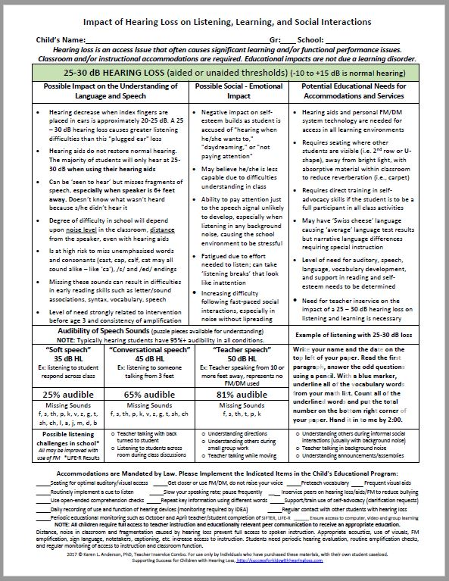
- The sections of possible impact on understanding, possible social/emotional impact, and potential educational accommodations have been thoroughly revised.
- Audibility of speech sounds for soft speech (35 dB), conversational speech (45 dB), and teacher speech (50 dB) have been included. A percent audibility is specified as are missing or audible speech sounds.
- An example of fragmented listening is provided via a paragraph of instructions with parts of speech eliminated based on decreased audibility.
- Possible listening challenges in school have been included, derived from the LIFE-R Student Appraisal. You can either check off the items that the student has identified as challenges, or leave them as is to raise awareness of difficult listening situations.
- The footnote contains a check off of important teacher accommodations that you can review to reinforce the necessary accommodations specified in the student’s IEP or 504 Plan.
- An instruction sheet has been included with suggestions for use with TODAY’S STUDENTS WITH HEARING LOSS!
What else comes in the Teacher Inservice Combo along with the newly revised Impact of Hearing Loss handout? 30 pages of resources not found on the Supporting Success website!
The Teacher Inservice Combo is fully digital and includes the following pdf handouts:
- Impact of Hearing Loss on Listening, Learning, and Social Interactions (5 pages)
- Emailable, computer fillable SIFTERs (Preschool, Elementary, Secondary) (6 pages)
- Emailable, computer fillable LIFE-R Teacher Appraisal (2 pages)
- Emailable, computer fillable Access to Curriculum Inventory (ATCI) for General Education Teacher (3 pages)
- Children with Hearing Loss Miss More Than You Think (1 page)
- Listening Comprehension Exercise – Mother’s Aprons (1 page)
- Barriers to Listening – Visual analogies of listening in noise, reverberation, and distance (5 pages)
- Student Listening Challenges – Understanding the Missing Pieces (1 page)
- Attitude is Caught, Not Taught (teacher version) (1 page)
- Hearing Aid/Cochlear Implant Monitoring and the Law (1 page)
- Hearing Aid Monitoring – An Important Daily Activity (4 pages)
- Emailable Tips for Teachers (Early Childhood + K-12) Word version (15 pages)
All 12 Inservice-related Materials in DIGITAL DOWNLOAD Format for only $39.00 on SALE through September for $33.00 [NEED TO INSERT LINK TO PRODUCT PAGE]

New version of the SSCHL website!

Our Supporting Success for Children with Hearing Loss website has a fresh, new look and is fully mobile accessible. More easily navigated, you will still be able to find the information you have learned to rely on. Visit the new website NOW!

We also have a new online shopping cart! View our Catalog and explore the beautiful layout of our selection of products. The new shopping cart supports multiple shipping carriers and a separate system for fair international shipping solutions.

More Resources for Easy Inservicing of School Staff and Classroom Peers
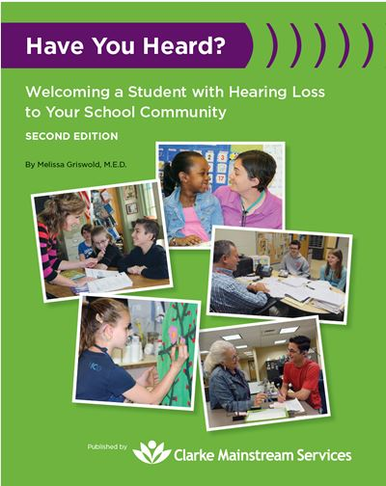
Raise student confidence 5 Ways to Say Good Day DVD for class peer inservicing Info for school staff

[need to insert links to product pages behind the images, hopefully Mail Chimp allows this! I’ve put in the links for the first 2. Have you Heard is a new product to be added to the new site.]

Teacher Tools

We are kicking off the Teacher Tools subscription year with over 500 members. Renew or join now!
[INSERT TT LOGO]
Our new Teacher Tools e-Magazine format is amazing! Like a real magazine, this digital version allows you to quickly flip through the pages to see the information most meaningful to you. All articles are downloadable for members to use with their caseload (not ‘freeware) and include many ‘use now’ handout type of teaching materials. 9 issues – September through May. Each issue is packed with downloadable teaching materials and relevant information for teachers of the deaf/hard of hearing!

See our FREE Promotional Issue to get the feel of this beneficial resource.
Read more about the articles you will find in our September issue.

Inside:
INSERT MINIATURE OF SEPT COVER AND Image of completed TOC BELOW:
All members will be able to access the Just for Members Library, Kool Kidz Vidz, and the Discussion Forum along with the monthly e-magazine.

What’s in the September Teacher Tools e-Magazine? Straight from the Zebra’s Mouth
Unique Aspects of Students with Hearing Loss
Areas of learning most likely to be impacted by hearing loss
Why Involve the Teacher of the Deaf?
Tech Talk
Technology Considerations to Improve Access, Involvement, Outcomes
Consistent Hearing Aid Use
Strategies for Language Instruction
Materials to use for Preschool, Elementary, and Secondary Students
Language Skill Development
Forming Sentences
Vocabulary Building Tools
World Coconut Day
Word Choice to Show Degree of Intensity
Knowledge into Practice
Summaries of Research for Improved Advocacy, Planning, Teaching
Using Data to Ensure High Standards
Strategies for Improved Interactions
Social Skill Development & Pragmatic Language
Self-Regulation and Role Models
Listening Skill Development
Listening for Key Information
Self-Advocacy Skill Development
Teen Thoughts from the Trenches - M
Self-Advocacy – Back to School!

Our Next Supporting Success Conference

[INSERT CONFERENCE LOGO]
More information to come soon. Set aside February 14-16, 2019 (yes 2019, not 2018) so that you can plan to attend the next Supporting Success for Children with Hearing Loss Conference. It will be held in Dallas, TX. We will be inviting Poster Sessions this year! Stay tuned!

Hearing Loss is an Access Issue – Not a Disorder. Share the news with Zebra Decal and Stickers

Call attention to the access needs of students with hearing loss! The decal is heavy plastic 5” diameter. Moisture resistant and moveable. Put it on your laptop, file cabinet, favorite tall drink container, car window, etc. The decal (1) comes with four 2” diameter stickers (non-removable) to call special attention to notes or permanent surfaces. An inexpensive way to make a statement! Read more

Inside
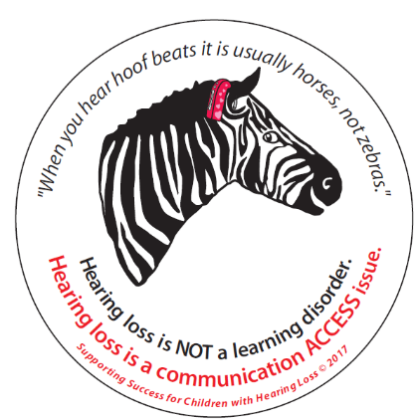
Unfortunately, the challenges of students with hearing loss are widely misunderstood. All too often, student learning issues are either minimized, ignored, or treated as though there is a disorder, rather than an access issue that needs specific access accommodations, supports, and specialized instruction.

The zebra logo, although simplistic, is a ‘call to arms’ for teachers of the deaf/hard of hearing and others who work with students who are deaf or hard of hearing, to advocate for their unique needs. Based on the popular saying, “When you hear hoof beats it is usually horses, not zebras” refers to the majority of students requiring specialized instruction due to various learning disorders as “horses,” and students with hearing loss, whose learning issues are secondary to reduced communication access as “zebras.”

One 5” heavy plastic, moveable decal + four 2” stickers for only $3.75.

More About the Topic – What’s on the Website?
[insert Supporting Success logo – blue ‘hands up’]
See the following SSCHL webpages for information related to the topic:
- Impact of Hearing Loss on Child Development & School Performance NEW! {Heidi add new link url please}
- Describing the Impact of Hearing Loss
- Inservicing the Classroom Teacher
- Demonstrations: Simulated Listening with Hearing Loss
- Relationship of Hearing Loss to Listening and Learning
- Accommodations for Students with Hearing Loss
Other Resources on Teacher Inservicing
Wait – There’s a Student with Hearing Loss Coming into My Class? Kym Meyer, educational audiologist presented this one-hour presentation via the Hearing Loss Association of America on 8/17/16. Download for free: webinar recording, PPT presentation, links to audio files. This webinar is a good example of material that can be covered when you inservice school staff.

Webcasts
[webcast logo]
Take advantage of our inexpensive Webcast Trio Combo Deals. Three $24, one-hour webcasts for the price of two ($48)! Choose the Ensuring Access, Academic Supports, or the Expanded Core Trio Combo. As always with Supporting Success webcasts you have 300 days to view your webcast(s) from the date of purchase. CEUs are available upon successful completion.

Inside:
Check out our complete Webcast Catalog. More webcasts are coming soon! Purchase online or by Purchase Order. Group pricing is available.
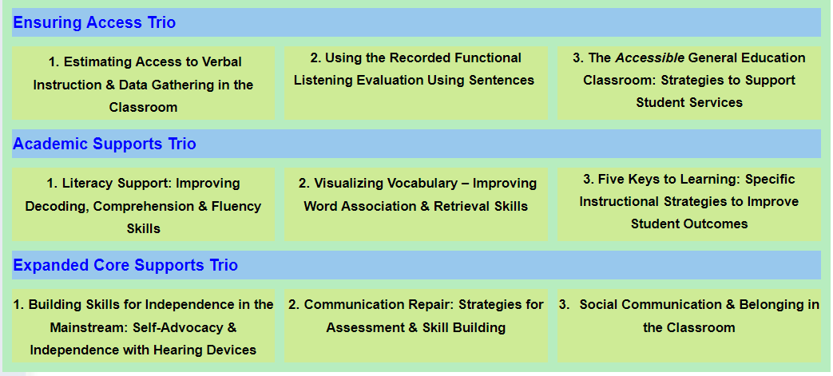


Advocacy Notes
504 Plans for Students with Hearing Loss
Question from the Field:
If a student has been identified with a significant hearing loss, but is academically at grade level with his peers, is it appropriate to give the student a 504 plan, as long as the student is able to receive direct services from a DHH itinerant for hearing and self-advocacy related skills?
What a great question. Read on for the response…

Inside:
The full question:

I work for a Co-op that has a number of teachers of the deaf/hard of hearing. Our team is having a discussion about when and if 504 plans are appropriate for students with hearing loss.

If a student has been identified with a significant hearing loss, but is academically at grade level with his peers, is it appropriate to give the student a 504 plan, as long as the student is able to receive direct services from a DHH itinerant for hearing and self-advocacy related skills? Are there legal protection differences that we should be considering?

If they are given an IEP initially, do you have suggestions for when a student is moved to a 504? Are 504 plans appropriate for students with hearing loss at the elementary and secondary level?

Can you respond for when students have hearing aids and use assistive devices and for those that do not use amplification?

All questions from the field are appreciated!
504 Plans are being implemented in different districts, which does make it confusing. The law, however, is clear:

- All students with hearing loss qualify for a 504 Plan because hearing loss is considered a life limiting issue. The requirements of the Americans with Disabilities Act are usually addressed with a 504 Plan.

- 504 Plans are appropriate for any age level.
- IDEA provides specialized instruction. It also typically specifies accommodations and instructional modifications. 504/ADA provides accommodations, including auxiliary aids and services. If the IEP provides sufficient accommodations to support the student in having an equal opportunity to receive classroom communication and to reach the same level of achievement, then a 504 Plan is not necessary. In many cases the IEP team will set up a minimal program for the student to progress in school, but not necessarily have the level of accommodations for equal access as required by ADA. If this is the case then a 504 Plan is necessary. See #4 for more about level of support via IDEA.
- As of March 2017, the level of support necessary via IDEA was clarified. The U.S. Supreme Court unanimously decided that full inclusion is the primary standard, with the "child progressing smoothly through the regular curriculum." The Court held that "merely more than de minimis" progress is not enough. Chief Justice Roberts wrote, "...IDEA demands more. It requires an educational program reasonably calculated to enable a child to make progress appropriate in light of the child's circumstances." If a child is not fully included, school officials must look at the child's unique needs and required level of specialized instruction before developing an IEP that is "pursuing academic and functional advancement." What does this mean for students with hearing loss? Yes, the decision can be understood as raising the bar for IDEA students. The Court was clear that this was the intent. However, many questions remain as to how this decision will apply in general, and definitively, as to how it will be applied to deaf and hard of hearing students.

- The ADA requirements restate the principles stated under Section 504, which is often seen as the means used to fulfill the requirements of ADA. Per the U.S. Department of Justice2: Public entities must not discriminate against, deny the benefits of, or exclude qualified individuals with disabilities from participation in any service, program, or activity. The aids, benefits, and services provided to persons with disabilities must be equal to those provided to others, and must be as effective in affording equal opportunity to obtain the same results, to gain the same benefit, or reach the same level of achievement as those provided to others. These requirements apply to all school-related communication for children with known hearing, vision or expressive speech impairments, ages 3 through 22, who are educated in public schools, including charter and magnet schools.
- US Dept of Education, OSEP Policy Document, January 13, 2010 (Topic: Evaluation Procedures)-to an individual (personally identifiable information redacted), regarding “twice exceptional students,” students who have high cognition and who have a disability and may need an IEP. MS Word l PDF
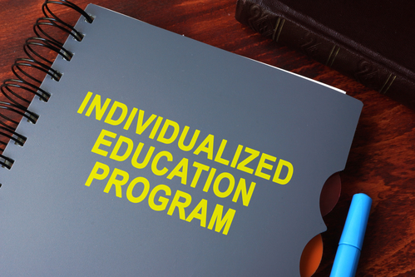
  - The letter states the Department's believes IDEA does provide protections for students with high cognition and disabilities who require special education services.
  - "The IDEA is silent regarding “twice exceptional” or “gifted” students. It remains the Department’s position that students who have high cognition, have disabilities and require special education and related services are protected under the IDEA and its implementing regulations."
  - My addition to a) and b) would be to say that even academically gifted children with hearing loss, or those achieving ‘good’ grades, require the expanded core curriculum skills – specifically individually designed special instruction in self-advocacy/communication repair skills. Full participation in the classroom requires these skills, especially since about 1/3 of class time is spent in group/discussion activities that are especially challenging for students with hearing loss. To reiterate what you may have heard me say before: IDEA considers educational performance needs broadly in the identification of special education needs. IDEA does not require academic delays. It requires adverse educational affect, or educational performance that is adversely affected. This can be obvious by functional assessment/observation of students with hearing loss, even if normative testing is within normal limits.
- CIs and HAs are assistive devices. Hearing aids often show up on the IEP as being necessary for the student to receive FAPE. If the student refuses to use the amplification (FM too) then it needs to be removed from the IEP otherwise the district can be later held liable for not providing for this need. We can’t MAKE students use the amplification. We CAN teach them self-advocacy skills that should allow them to provide for the lack of amplification. Well, we know that there is not a replacement for being able to fully access communication from infancy. We have to keep in mind that sometimes students who are hard of hearing purposely stop using their devices so that they will ‘fit in better’ even if that means being educated ‘like the LD kids’ that are much more prevalent than students with hearing loss. Regardless, each situation in school should be reviewed for necessary accommodations, meaning auxiliary aids and services per ADA (and showing up on 504 plans). This worksheet was developed to assist in this process. For example, services for students who do not have IEPs can include teacher inservice, teaching use of amplification, monitoring functional classroom performance, even self-advocacy skill development – although self-advocacy is usually provided under an IEP.
- Bottom line in my mind is – students with hearing loss require accommodations in school if they are not to be discriminated against. The IEP can provide these accommodations/auxiliary aids/services. If there is no IEP OR if the IEP does not provide sufficient accommodations to result in equal access to classroom communication, then a 504 Plan is appropriate. A student CAN have both an IEP and a 504 Plan.
If you have a question from the field, send it to karen@successforkidswithhearingloss.com!
NOTE: The information represents the opinion of Karen Anderson, PhD who is not an attorney. The information presented is not legal advice, may not be the most current, and is subject to change without notice.

What is Interact-AS? Captioning by a Computer!
For some students, having what the teacher says show up as text on a media device at their desk is just the accommodation they need to be able to keep pace. Plan to join us for the next free webinar to discuss Interact-AS Speech-to-Text Captioning – September 20th, 2:00 PM Central time zone. I am waiting to receive the registration info to link here.

Read more about this accommodation

Inside:
Plan to join us for the next free webinar to discuss Interact-AS Speech-to-Text Captioning – September 20th, 2:00 PM Central time zone. I am waiting to receive the registration info to link here.

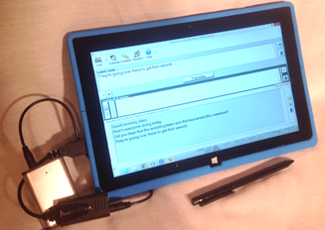
Our students need equal access to classroom communication. Hearing devices, including FM/DM systems, do not restore normal hearing ability. As students reach upper elementary and the secondary grades it is very hard to keep up with the pace of vocabulary learning due to reduced auditory access. Being able to read the captions within 1-2 seconds of the teacher’s utterance can provide an important edge for keeping pace in the classroom.

Read: Classroom Captioning: Interact-AS is Making a Difference in Listening Comprehension

Overview video – a day in the life of a student


Upcoming Presentations
by Karen Anderson, PhD, Director of Supporting Success
September 22 – ND (Minot)
October 12-13 – LA (Lafayette)
October 19-20 – MA (Marlborough)
November 2 – MB (Winnipeg)
Schedule now for a presentation in 2018! Read here for more detail

Inside:
Contact info@successforkidswithhearingloss.com for more information on specific speaking engagements. Refer here for more information on presentation services.
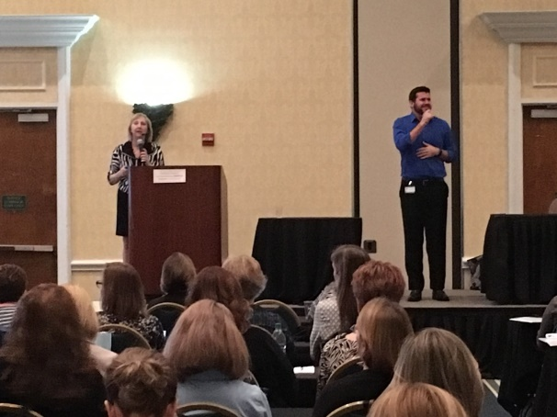
September 22, Minot, ND. Friday Symposium celebrating the 200th year of deaf education in the US and the 55th year of the DHH teacher prep program at Minot State University. Keynote + sessions.

October 12-13, Lafayette, LA. Speech Pathologists and Audiologists in Louisiana Schools conference. Cajun Dome. 1 full day.

October 19-20, Marlborough, MA. Presentations at the Clarke Annual Mainstream Conference.

November 2, Winnipeg, MB. Conference for educators and other related professionals who work with students with hearing loss. 1 full day.

