Steps to Assessment
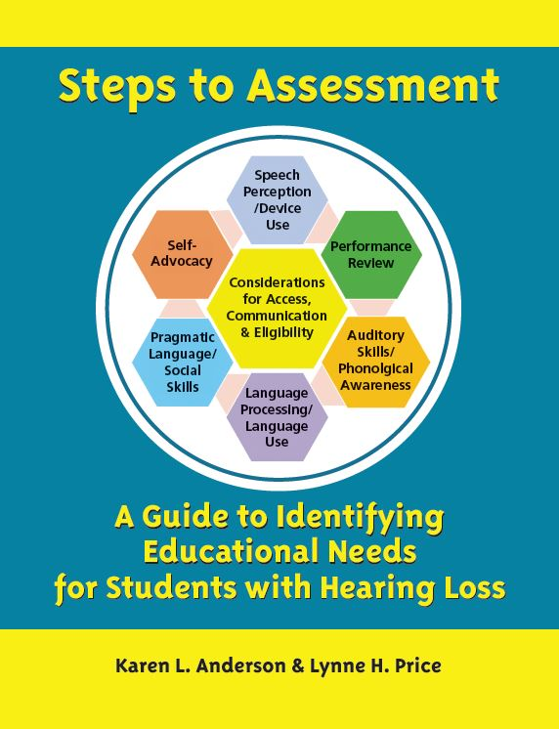
The focus of this guide is assessment from transition to school at age 3 through high school. Categories of assessment are presented, as are ways to tease out information from assessment results to illustrate how to identify needs to support eligibility. A variety of assessments are described for each assessment area. Case examples show how the teacher can choose appropriate test instruments and interpret the results, including determining possible goal areas. Self-learning application activities help readers to integrate the information into daily practice.
Teachers who use this 290-page guide will have a much better understanding of the vulnerable areas of development due to hearing loss, how the areas interconnect, and ultimately how they are the experts in using the ‘deaf lens’ to contribute to their evaluation teams and service planning.
Hearing loss is an access issue that often causes listening, language, attention and social challenges for children learning in a typical classroom environment. Only 1% of children who have IEPs are qualified under a primary disability category of hard of hearing or deaf. Because of this, the learning challenges they experience in school are often overlooked or mistaken by school staff as being due to other issues. It is critical for the teacher of the deaf and hard of hearing to be able to collect the data needed to identify access to verbal instruction and student needs in the areas vulnerable due to hearing loss and use this information to develop appropriate programs.

Introduction
Why this guide is needed
Clarification of Title II of the ADA – a ‘game changer’
Using the “deaf lens” to interpret assessment information
Format of the Steps to Assessment guide

Chapter 1: The Assessment Process
What is assessment?
Qualifications of evaluators
Analysis of student behavior and response
Steps in an effective evaluation
Process of data collection

Chapter 2: Speech Perception and Device Use
History of Device Use
Interpreting the audiogram meaningfully
Planning speech perception assessment $50 per copy or $212 for 5 copies
Assessment of precision listening: Preschool and School-age shipped to one address
Assessment of functional listening: Preschool and School-age
Case examples
Chapter appendices
10 Questions about Your Child’s Hearing Aids – parents and students
Cumulative Hearing Device Monitoring Results
Functional Interpretation of Hearing Thresholds on the Audiogram
ELFLING: Ling Sound Listening Bubble Checklist for Young Children
AB Short Word List
Lexical Neighborhood Test / Multisyllabic Lexical Neighborhood Test
Suggested Tools to Assess Speech Perception and Hearing Device Use

Chapter 3: Performance Review
Why do a performance review?
Parent involvement
Determining eligibility for specialized instruction and related services
Documenting the performance review process for eligibility
Functional performance data-gathering tools
Classroom observation
Parent or Teacher Checklists/Interviews

Chapter 4: Auditory Skills Development
What are auditory skills?
Why assess auditory skills?
Auditory skills assessment: Preschool and School-age
Case examples
Chapter appendices
Listening Skills Develop Early – A Hierarchy of Auditory Skills Learned by Age 4 Years
Checklist of Auditory Skills for Classroom Success: Hierarchy of Auditory Skill Development
Suggested Materials to Use with Young Children
Mr. Potato Head Task
Suggested Tools to Assess Early Auditory Skill Development

Chapter 5: Prosody, Phonologic Awareness, and Morphology
Prosody: Prosody skills assessment
Phonology: Phonological awareness assessment
Morphology
Case examples
Chapter appendices
Formant (Frequency Band) Characteristics of Vowel and Consonant Sounds (Hz)
Pre-Feature Identification Contrasts (PreFICs)
Technical Adequacy of Phonological Screening and Monitoring Measures

Chapter 6: Language Processing and Use
Components of language development
Assessment of language processing and use: early childhood and age 3 and above
Chapter appendices
Tools Described to Assess Language Development/Processing

Chapter 7: Social Interaction: Pragmatic Language Use and Social Skills
Definitions of issues
Evidence of issues in these areas for children with hearing loss
Preschool, Elementary and Secondary - social interaction skills assessment
Pragmatic language
Theory of Mind conceptualization
Self-concept / social-emotional development
Social skills
Case examples
Chapter appendices
Suggested Tools to Assess Social Interaction Skills and Abilities

Chapter 8: Self-Advocacy, Self-Determination and Independence with Amplification Devices
Context for self-advocacy skill development
Self-advocacy as a means to improve functional achievement
How is self-advocacy relevant to school achievement?
What is self-advocacy?
Self-advocacy assessment
Knowledge of hearing loss
Independence with hearing devices
Communication repair skills
Self-advocacy skills
Self-determination
Case examples
Chapter appendices
SEAM – Student Expectations for Advocacy & Monitoring Hearing Technology
Hearing Aid Independence & Self-Advocacy Skill Expectations Checklist
Functional Assessment of Hearing Device Independence Skills
What Can YOU Do to Help Yourself? Self-Advocacy Strategy Checklist
Self-Advocacy Quiz
Suggested Tools to Assess Self-Advocacy Skills

Chapter 9: Students with Additional Challenges
The Visual Language Learner – Use of Manual Communication Systems
Other disabilities
Culturally and Linguistically Diverse Learners

Self-Learning Application Activities for Individual and Professional Learning Communities
Self-Learning Application Activities – Part 1: Vocabulary
Self-Learning Application Activities – Part 2: Engagement & Practical Application
Appendices
Steps to Assessment: Vocabulary
Assessments Currently Used in Our Schools
Assessments to Consider Adding in Our Schools
Evaluation Practices – Who Assesses with What Tool? NOW
Evaluation Practices – Who Assesses with What Tool? FUTURE
Assessment Practices Improvement Plan
Assessment Time Study

