Acoustic Transparency Comparisons of Hearing Aid Retention Accessories

RESP 50 - volume control taped so it remains stable throughout evaluation
Set-up of hearing aid with retention accessory | 200 | 250 | 315 | 400 | 500 | 630 | 800 | 1000
Hearing aid only | 63 | 65 | 71 | 72 | 75 | 79 | 84 | 90
Hearing aid on false ear (pinna effect) | 64 | 68 | 70 | 73 | 75 | 78 | 82 | 90
Hearing aid on false ear with Ear Gear | 61 | 67 | 70 | 72 | 76 | 79 | 83 | 89
Hearing aid on false ear with Hanna Andersson cap | 63 | 67 | 70 | 73 | 75 | 78 | 82 | 91
Hearing aid on false ear with Silkawear cap | 63 | 67 | 70 | 73 | 75 | 78 | 82 | 91
Hearing aid on false ear with Hearing Henry headband | 63 | 67 | 70 | 69 | 74 | 79 | 82 | 86

Set-up of hearing aid with retention accessory | 1250 | 1600 | 2000 | 2500 | 3150 | 4000 | 5000 | 6300
Hearing aid only | 99 | 93 | 87 | 87 | 86 | 83 | 74 | 55
Hearing aid on false ear (pinna effect) | 99 | 94 | 91 | 95 | 91 | 85 | 75 | 56
Hearing aid on false ear with Ear Gear | 98 | 91 | 88 | 93 | 89 | 83 | 73 | 54
Hearing aid on false ear with Hanna Andersson cap | 100 | 96 | 93 | 95 | 93 | 88 | 79 | 56
Hearing aid on false ear with Silkawear cap | 100 | 96 | 93 | 95 | 93 | 88 | 79 | 56
Hearing aid on false ear with Hearing Henry headband | 91 | 84 | 79 | 84 | 88 | 79 | 68 | 48

GAIN IN dB
Set-up of hearing aid with retention accessory | Average  OSPL90 | Average gain@50 | Average gain@60 | Frequency  Range
Hearing aid only | 109 | 30 | 30 | 300-5600
Hearing aid on false ear (pinna effect) | 109 | 32 | 33 | 375-5600
Hearing aid on false ear with Ear Gear | 109 | 31 | 31 | 315-5340
Hearing aid on false ear with Hanna Andersson cap | 109 | 34 | 34 | 420-5600
Hearing aid on false ear with Silkawear cap | 109 | 34 | 34 | 420-5600
Hearing aid on false ear with Hearing Henry headband | 108 | 24 | 24 | 200-5340

HARMONIC DISTORTION
Set-up of hearing aid with retention accessory | 500 Hz | 800 Hz | 1600 Hz
Hearing aid only | 2 | 1 | 2
Hearing aid on false ear (pinna effect) | 3 | 2 | 2
Hearing aid on false ear with Ear Gear | 3 | 1 | 1
Hearing aid on false ear with Hanna Andersson cap | 2 | 1 | 1
Hearing aid on false ear with Silkawear cap | 2 | 1 | 1
Hearing aid on false ear with Hearing Henry headband | 2 | 1 | 2

Phonak Piconet2 (P2AZ) hearing aid used for assessment. Set volume backed off slightly from full on and taped into position.
Refer to next page for photos of acoustic transparency assessment set up.
Performed October 2013 by Vickie Anderson, AuD and Karen Anderson, PhD using an AudioScan electroacoustic hearing aid analyzer.
Acoustic Transparency Assessment of Hearing Aid Retention Accessories

Hearing aid on false ear (to account for pinna effect) with Ear Gear
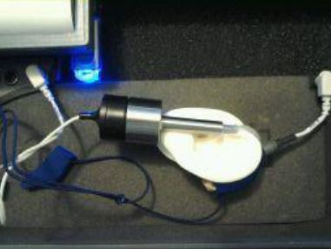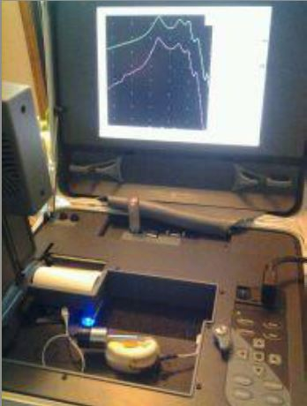
Hearing aid covered by Silkawear cap and Hanna Andersson pilot cap
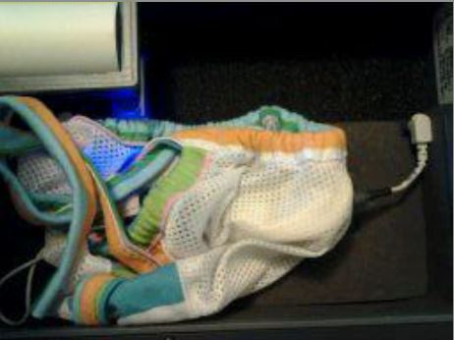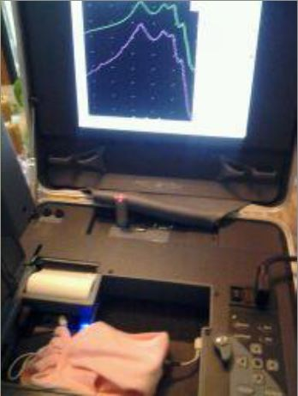
Hearing aid covered by Hearing Henry Headband
