Ethnic Diversity and Hearing Loss [STUDY]

The Changing American Family & Ethnically Diverse Children with Hearing Loss and Multiple Needs
Ellen A. Rhoades, Ed.S., C.E.D., Cert. AVT, Fiona Price, Ph.D., & Christina Perigoe, Ph.D., CCC-SLP, C.E.D., Cert. AVT
http://listeningandspokenlanguage.org/Document.aspx?id=467

Introduction
The population of the United States is becoming more and more diverse. By 2050, experts predict that minorities will comprise close to 50% of the national population (Caesar & Williams, 2002; Nelson, Palonsky, & McCarthy, 2004). There have also been significant changes in the way diversity is perceived and managed in U.S. society. In the middle of the 20th century, the ideal model for a multicultural society was the melting pot, where minority groups progressively relinquished their cultural values and practices and adopted those of the majority culture (Glazer & Moynihan, 1963). This model is now being abandoned in favor of a ‘mosaic’ model of cultural pluralism, where minority groups participate fully in society while retaining their distinctive cultural values and practices (Stockman, Boult, & Robinson, 2004).
These changes in the composition and attitudes of U.S. society have important implications for professionals in auditory-based practice. The high rate of immigration from developing countries, where hearing loss is more prevalent, is leading to a growing number of children with special needs that do not share the same culture of most auditory-based clinicians. In order to meet the challenges of a multicultural society, professionals working with children who are deaf or hard of hearing will need to develop the skills and knowledge to manage diversity effectively.

People Receiving Services
At present, auditory-based intervention programs are not equally serving children from all cultural groups. Caucasian American children from affluent families have greater opportunities to access Auditory-Verbal therapy (Easterbrooks, O’Rourke, & Todd, 2000). Children from this demographic group represent the majority of those who receive cochlear implants (Gaulladet Research Institute, 1998; Geers & Brenner, 2003), and have been shown to perform better on speech recognition tests (Niparko, 2003). Research also suggests that economically advantaged White children are less likely to attend public schools for the deaf, where the proportion of non-White students is considerably higher than would be expected (Bagli, 2002; Fischgrund, Cohen, & Clarkson, 1987).
Professionals working with children who are deaf or hard of hearing need to develop an awareness of how diversity issues affect their clients. Their understanding of the impact of ethnic, cultural and linguistic diversity, income, and family structure greatly improves their ability to deliver effective Auditory-Verbal therapy. Professionals who are well informed about these issues are better equipped to inform families about different communication and educational options and advocate for ethnically diverse families. They are also in a better position to help families advocate for their own children within the school system.

Family Structure
The traditional one-income nuclear family has become considerably less common in the U.S. over the past 50 years. In many households, both parents are now working, which has led to a shift in child-rearing practices, with many children being cared for by other relatives or professional caregivers for much of the day. Divorce rates have risen to over 50% in the U.S., and as a result, about 25% of American children currently live in single-parent households (Clark, 1995), and about 5% are stepchildren within blended families (Kreider, 2003). Adoption rates are rising, with about 3% of young American children adopted (Kreider, 2003). The growing acceptance of homosexuality has paved the way for children being born or adopted into families headed by a gay couple, with at least 2 million gay and lesbian couples now raising children (Harper, Jernewall, & Zea, 2004; Patterson, 1992). There is also a widespread recognition that unhealthy family dynamics are becoming more common throughout the U.S. (Schwartz, 1997).
Changing family structures and boundaries are having a significant impact on the work of auditory-based professionals. Families who have children with special needs are susceptible to disruptions in family structure, even more so in families who are not of the majority culture (Carter & McGoldrick, 1980; Guerin, 1976; Minuchin, 1974). They have a higher rate of both divorce (Naseef, 2001) and unhealthy familial relationships (Lambie & Daniels-Mohring, 1993; Powers, Elliott, Patterson, Shaw, & Taylor, 1995). Auditory-based professionals need to be aware of how family structure can impact on their work, both in terms of the child’s home environment and in terms of the practical considerations involved in working with the child’s caregivers.
Income
Poverty is also an important factor. Living in poverty makes children more vulnerable to hearing loss and associated disabilities, as they often face inadequate medical care (Capps, 2003; Elster, Jarosik, VanGeest, & Fleming, 2003; Thompson, Ryan, Pinidiya, & Bost, 2003), higher rates of recurrent serous otitis media, lead poisoning, and poor nutrition (Mendola, Buck, & Starr, 1994). The needs of low-income caregivers are great, as their parenting behaviors are mediated by their psychological well-being and literacy (Yeung, Linver, & Brooks-Gunn, 2002). Poverty may also limit children’s access to stimulating learning environments. A low-income family, struggling to provide basic necessities, may have little time or resources to devote to advocating on behalf of their child or teaching their child how to listen, speak, and read.
The extent of the poverty problem in the U.S. is serious. In 2002, the documented poverty rate in the U.S. was 12.1% (nearly 35 million). Of these, approximately 12 million were children (Proctor & Dalaker, 2002; U.S. Census Bureau, 2003). The poverty rate was nearly double for African Americans (23.9%) and Hispanic Americans (21.8%) (U.S. Census Bureau, 2003). Poverty is a particularly serious problem in single-parent families, where the poverty rate for children under age 6 in single-parent homes is 49% (Children’s Defense Fund, 1999; Proctor & Dalaker, 2002). In such homes, caregivers may have low levels of education or English language difficulties, and they may misunderstand or misconstrue information presented to them by the therapists. It is particularly important that therapists work effectively with such families, encouraging them to provide their child with sufficient language input. Listening and language activities which fit into the family’s natural interactions and routines are particularly helpful.

Language
As described previously, families who speak languages other than English at home present unique challenges for auditory-based therapists. Figures from the 2000 U.S. Census indicate that such families comprised about 18% of the American population, with higher proportions in certain states, such as Texas (31.2%) and California (39.5%) (U.S. Census, 2000).
The fastest growing minority group in the U.S. is Spanish speakers (Ramirez & de la Cruz, 2003), among whom the percentage of children who are deaf or hard of hearing has been steadily increasing (Gallaudet Research Institute (GRI), 2001, 2002, 2003a, 2003b). Of the households that have a child with hearing loss, 11.5% of families are Spanish speaking, 2.8% speak other languages, and 9.5% of families speak multiple languages (GRI, 2003b). Note also that the issue of language is more complex than many people may realize. For example, there are many dialects of Spanish spoken in the U.S., and African-Americans may speak a dialect of English different from that used by many middle-class Caucasian Americans (Seymour, Abdulkarim, & Johnson, 1999).
As discussed earlier, it is now considered ideal for people from minority cultures to retain their unique values and language. Nonetheless, research suggests that, although 1 in 4 children enters school speaking a language other than English, most of them subsequently lose their native language as they learn English (Peyton, Ranaard, & McGinnis, 2001). When teaching children with hearing loss, professionals need to recognize that many immigrant and indigenous people wish to preserve their languages and cultures as well as mastering English.

Ethnic and Cultural Diversity
Ethnic minority groups constitute approximately 28% of the U.S. population (U.S. Census, 2000), and the percentage continues to increase (Hodgkinson, 1994), particularly in perimeter states of America. In certain areas, such as Dade County, FL and Queens County, NY, about half of all residents are foreign-born (Schmidley, 2003). Children of color are also the fastest growing segment of the U.S. population (Hopkins, 1997), in particular Asian Americans, who are increasing at a rate of 39%, and African Americans, who are experiencing a 14% increase. By contrast, White Americans are experiencing only a 2% population increase (Smith, 2001).
Of particular relevance to professionals working with children who are deaf or hard of hearing is the rate of hearing loss among children in different ethnic groups. Due to the preference of many ethnic groups for consanguineous marriages and the smaller pool of available partners (Bagli, 2002), children of color often exhibit a higher rate of inherited disabilities, including hearing loss. Survey data show that about 49% of children with hearing loss are non-White, of whom 15.4% are African American, 24.5% are Hispanic American, 4.3% are Asian American or Pacific Islanders, .8% are Native American and 3.8% are listed as ‘Other’ or multi-ethnic (GRI, 2003b). It is therefore likely that most auditory-based therapists in America will be working with children of color during their careers.
Working with children from different cultural backgrounds presents some unique challenges for professionals. Although it is important not to be bound by stereotypes about particular cultures, it is also important to remember that different cultures often embrace different views about parenting, teaching, disability, and other issues involved in the work of auditory-based clinicians. For example, among middle class White Americans, it is generally expected that primary caregivers will take a proactive role in educating children with disabilities to live a normal, independent life. In other cultures, primary caregivers may regard disability as a shameful reflection on their conduct and endeavor to conceal their child with disabilities; in still other cultures, a child with disabilities may be seen as a gift from God, with caregivers believing that the child will naturally remain dependent on them and that invention and education represent an interference with God’s will (Bennett, Zhang, & Hojnar, 1998). Therapists who understand the cultural values of the families with whom they are working are better equipped to manage any difference in expectations between their own goals and those of the child’s caregivers.
Racial discrimination is another important issue to recognize when working with ethnically diverse children. Although few Americans express openly racist attitudes today, research still suggests that White Americans continue to perceive other racial groups more negatively than their own (Gilliam, 1988). African Americans tend to be rated most negatively of the ethnic groups in the U.S., followed by Hispanic Americans (Caesar & Williams, 2002; Glazer, 1997). Racism can exist within and between minority groups as well; within the African American community, there can be prejudice based on the lightness of skin color, and within the Hispanic American population, some individuals are considered White and others Black. Professionals need to be conscious of the demoralizing effects of racial discrimination, and strive to look beyond racial stereotypes in their work with children of color.

Children with Additional Learning Challenges
A significant proportion of children with hearing loss have one or more co-occurring disorders. According to the 2002-03 annual survey of deaf and hard of hearing children (GRI, 2003b), nearly 40% of children with hearing loss have other special needs: 10.2% have an identified learning disability; 9.3% are cognitively delayed; 6.6% have attention deficits; 4.4% are visually impaired; 3.3% have cerebral palsy; and, 14.5% have other special needs. Note that these may be underestimates, as they omit some children who are fully mainstreamed in the private or public school sector and children with unidentified disorders.
The same or a higher proportion of co-occurring disorders in children with hearing loss is found in cultural minority groups (GRI, 2003a). Causes of hearing loss which can be associated with other etiologies such as cytomegalovirus, premature weight, meningitis, maternal rubella, sickle cell disease, and HIV are disproportionately common among African Americans and Hispanic Americans (Scott, 2002). Deaf-blindness is significantly higher among Asian Americans (Bagli, 2002). It has also been argued that the experience of children with hearing loss from linguistic minority cultures may be similar to that of children with additional learning needs.

Becoming a Culturally and Linguistically Competent Professional
Details on the cultural backgrounds of people working in the hearing loss field are difficult to obtain, but available data in the U.S. suggest that the great majority of professionals working with children who are deaf or hard of hearing are Caucasian Americans. Figures from the American Speech and Hearing Association (ASHA) indicate that 95% of members are Caucasian Americans. Among special educators, 86% are Caucasian American, 1% African American, and 4% Hispanic American (Boyer & Mainzer, 2003), and among audiologists, 80% are English speakers (Ramkissoon & Khan, 2003). No details on the cultural origins of the professional membership of the Alexander Graham Bell Association for the Deaf and Hard of Hearing (AG Bell) or Auditory-Verbal International (AVI) are currently available, but it would not be surprising if the majority of auditory-based therapists in the U.S. were English-speaking Caucasian Americans. There is also evidence that special educators are mostly female (85%) and that fewer special educators teach in districts with high poverty rates (Boyer & Mainzer, 2003).
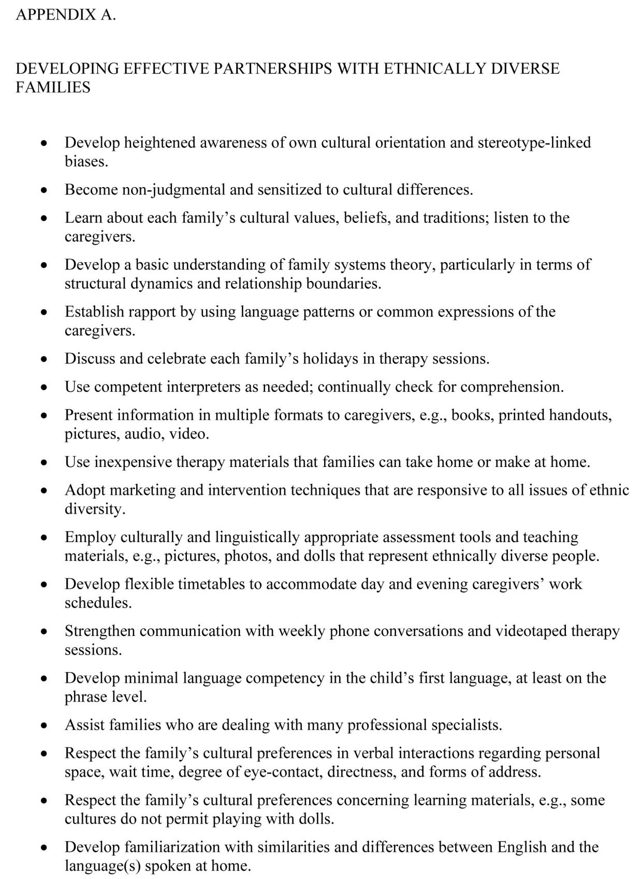
Overall, evidence suggests that the background of auditory-based therapists in the U.S. does not reflect the ethnic and demographic diversity of the families they serve. It would be helpful to obtain further data on the ethnic diversity to determine the extent of this problem and work towards resolving it. Given the restricted cultural backgrounds of professionals who currently work in the field, it is particularly important that these professionals develop their cultural and linguistic competence, so as to facilitate effective therapy across all cultural and demographic groups. This involves not only respecting and learning about other cultures, but also developing an awareness of one’s own cultural beliefs and practices, and how these shape the way people teach, parent, and communicate.
People from all cultures value their children, but express their care in different ways, depending on ethnicity, language, gender, class, sexual orientation, and their own experiences. Recognizing this helps multicultural therapists to respect these differences and adapt to the unique needs of the families they encounter. In this way, they can become ‘cultural brokers’ (Harris, 1999), who can bridge the gap between minority groups and mainstream culture. For more suggestions on how to develop effective partnerships with ethnically diverse families, see Appendix A.
In order to become cultural brokers, therapists must become as informed as possible about the cultural values of the family with whom they are working. The many texts on multicultural education are a good place to start (e.g., Banks, 2000; Battle, 2002; Cushner, McLelland, & Safford, 2003; Kalyanpur & Harry, 1999; Lynch & Hanson, 2004; Smith, 2001). These tend to outline common areas of cross-cultural difficulty with particular groups, and often provide some general ideas for professionals as to how to manage them. See also Appendix B for a list of online resources. For specific information, it is useful to read recent research on the culture and contact ethnic community groups for information. If possible, an excellent way to gain an understanding of a particular culture is to find someone who is competent in both the therapist’s culture and the culture of the family, who can serve as an interpreter.
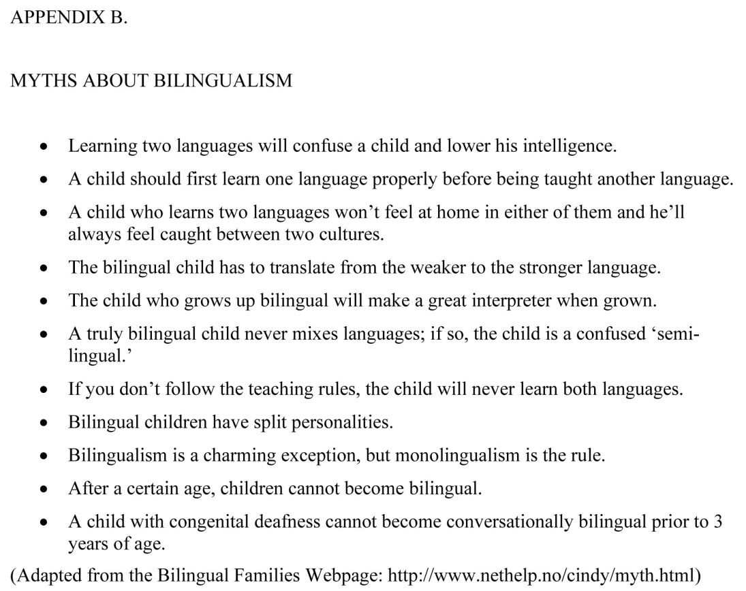
After establishing some background information on the culture with which therapists are working, the next step is to explore the specific circumstances of the family. It is important to remember that not every family will fit the typical profile of their culture. Ideally, the therapist should conduct an informal interview with the family, having first established through other sources which topics of discussion are likely to be sensitive or taboo, and how to best to raise these, if doing so is important. Issues that should guide the conversation include:
• What they think caused their child’s hearing loss, and how they feel about their child’s disability.
• What they feel their responsibilities are regarding their child’s disability.
• What they expect therapy to achieve, and how they believe a good teacher or therapist should behave.
• For newly immigrated families, how long they have been in the U.S., and their experiences in U.S. society.
• Their child rearing practices, in terms of their aspirations for the child, disciplinary techniques, and education.
• Their religious beliefs, language, and family roles. For example, whether extended family members are present, and, if so, what role they play in the child rearing, who makes the major decisions regarding the child.
Ideally, this guided conversation should lay the foundation for an understanding of the family culture and dynamics and facilitate the development of trust and rapport between the family and the therapist. It should also help to preempt the three major areas of potential cross-cultural difficulty – the nature of the intervention, discipline, and family dynamics and stress.
The nature of the intervention used with children who are deaf or hard of hearing in the U.S. may seem inappropriate or odd to caregivers raised in other cultures. Some caregivers may be baffled at the notion of collaborating with the professional in educating their child; in their experience, education is a job completely handled by professionals who are not to be questioned. Caregivers raised in cultures where professionals command fear and respect and deliver knowledge to children can be taken aback by the more interactive, personal approach adopted in the U.S.; therefore, these caregivers may consider American professionals insufficiently serious. In order to minimize tension arising from differences in expectations such as these, therapists should provide families with a jargon-free, easy to understand explanation of the intervention, including projected outcomes, and the techniques used help to achieve them (Harris, 1999).
Managing the child’s behaviors in various situations is another area where tension can arise between the therapist and caregivers. This is often related to cultural differences in behavioral expectations. It may be further complicated by the family’s attitude towards the child’s disability, which may lead them to be more accepting or even reinforcing of negative behaviors. Again, it is helpful to establish what caregivers consider to be appropriate behavior and discipline early on in the intervention, and explain what is expected of children during therapy. If the caregivers have other children without hearing loss, it can be beneficial to ask about discipline practices used with them. With consistent expectations, the child can develop appropriate behavior in the therapy or school environment, even if there are different expectations at home.
A third area that can give rise to difficulty is the dynamics within the family. Therapists should bear in mind that the child’s parents may not necessarily be the only or primary caregivers in all families, and therapists should try to do their best to establish the roles of different family members in the child-rearing process. They should be careful to use the terms parent/guardian in written case histories and questionnaires, and try to involve all members of the child-rearing team in the intervention where possible. It can be helpful to provide weekly videotaped sessions or telephone calls to the family, especially when primary caregivers are absent, so that the family can stay informed about the child’s progress. If possible, therapists should be given a flexible work schedule, so that they can provide therapy in the early morning or evening, if that better suits the family.
Therapists may also become conscious of stresses between family members that may affect the child. It may be useful for therapists encountering such problems to gain a basic knowledge of family systems theory, which can help them identify when the family is dysfunctional and therapeutic intervention might be necessary. For families who may not have an adequate support network, it may also help to put them in touch with other families of the same ethnic or cultural group who have children with special needs.

Managing Language Issues
A particularly pressing problem when working with families of multicultural backgrounds is that of language. Numerous difficulties can arise when the therapist and family do not have a common, fluent language. Some of the more prominent of these are outlined below.

Assessing the Child
Conducting reliable assessments of a child’s progress is a critical component of auditory/oral or Auditory-Verbal intervention. When the caregivers speak limited or no English and the child either has no verbal language or speaks only the caregiver’s native tongue, assessing progress can be problematic (Hodgson & Montgomery, 1994). Although the Individuals with Disabilities Education Act (IDEA) (U.S. Dept of Education, 1997) states that children must be assessed in their primary language, there are currently very few assessments available in languages other than English and Spanish. It should, therefore, be a priority to develop cross-culturally valid measures for assessing global and specific language competencies upon commencement of early intervention and employ clinicians who can conduct evaluations in the child’s language to identify communication difficulties.

Communicating with Caregivers
Given that auditory-based therapists collaborate with the child’s caregivers in their work, it is important that communication and assessment be ‘parent-friendly’ (Rhoades, 2003). For families from diverse cultural backgrounds, it may be necessary for the therapist to coordinate the services of other professionals, such as interpreters and translators, and maintain continuity of intervention from several professionals. Bear in mind that some caregivers may come across as passive, because in their culture they would not be expected to provide input to ‘experts.’ In terms of language, note that even where caregivers do speak some English in addition to their primary language, it is advisable to check their understanding of what is said during sessions, use face-to-face interaction where possible, and provide written follow-up at an appropriate level of English. It may also be helpful to use non-print visual support, e.g., photos, charts, or drawings.
The use of interpreters warrants further comment. Where possible, interpreters with high oral and written proficiency in English and the caregivers’ language should be employed (Langdon, 2002). Ideally, the therapist should employ the interpreter in advance, and debrief and review each therapy session with them. Interpreters should have a good understanding of the two cultures’ communication styles, and be conscious of the length and pace of what is said. They should be able to render the meaning of what is said in both languages with integrity and fidelity, maintain confidentiality, and interpret in a neutral and honest way.

Bilingualism
The issue of bilingualism is one that commonly arises with families of different cultural backgrounds. A child who is fully bilingual is one who can communicate with conversational fluency in two languages from an early age (Bachman, 1990; Hart, Lapkin, & Swain, 1987). Bilingualism is considered to be advantageous for children. Compared with monolingual children, bilingual children have been found to have higher metalinguistic awareness, better communicative sensitivity, and a greater level of divergent thinking and creativity (Baker, 2001). In addition to this, many families from cultural minorities feel strongly about retaining their native language and want their children to speak it. It is therefore important that auditory-based therapists and caregivers work together to facilitate the child’s development in both English and the language of origin, with the help of a competent and reliable interpreter (Thomas & Collier, 1997).
Research on bilingualism suggests a number of things that are relevant to therapists. Researchers have found that it is best for children under 3 to acquire natural conversational language as spoken in the home until the child reaches a competency level of at least 2 years of age in that language (Baker, 2001). This lays down a foundation from which a second language can be acquired. This has been found to be most effective when language boundaries are consistent, such as having a “one parent, one language” situation at home (Baker, 2001), or having one language spoken at home and another at school (Harding & Riley, 1986). This helps the child develop the ability to ‘code-switch,’ or switch from one language to another as they change contexts (Baker, 1995).
Early exposure to spoken language in the mother tongue is especially important for the development of speech perception in children who are deaf or hard of hearing. Of particular importance is exposure to suprasegmental speech patterns, such as phrasing, and the use of different registers for people in different roles, which the child needs to master in order to communicate appropriately. Note, however, that it is not necessary for the child to master the mother tongue before starting to learn English. Once the child reaches a receptive language level of two years of age, both languages can be acquired simultaneously (Baker, 1995; Collier & Thomas, 1999; Walters, 1998).
Given appropriate hearing technology and education, children with hearing loss from other language groups are capable of achieving bilingualism. It is important to guard against the many myths about bilingualism (see Appendix B). It should, however, be mentioned that children from bilingual homes may face particular difficulty if they also have neurodevelopmental dysfunction or other special needs, such as a working memory deficit (Ardila, 2003). Such children may need special assessment and attention to their needs. However, it is also important to remember not to confuse the sort of language and language difficulties experienced by second language learners with language and learning disorders (Ortiz, 1997; Salend & Salinas, 2003; Smith, 2001). Children with hearing loss from bilingual homes may not perform as well as their monolingual peers because of the challenges presented by a bilingual environment, rather than their academic or linguistic capacity (Bennett, 1988). For example, difficulty with a particular aspect of language use, such as the pronunciation of final consonants, may, in fact, reflect the language spoken at home (e.g., many Asian languages do not have final consonants), rather than learning difficulties in the child. For therapists working with children from other language backgrounds, it may be helpful to familiarize themselves with the patterns and parameters of the family’s native language.
A final issue to consider when working with children who are deaf and hard of hearing who use another language is listening in the presence of background noise. Data show second language learners to be more negatively affected by noisy environments (Mayo, Florentine, & Buus, 1997; van Wijngaarden, Steeneken, & Houtgast, 2002; van Wijngaarden, 2001). This is particularly worrisome in the context of the report that nearly 39% of children with hearing loss do not wear hearing aids for instruction and over 60% do not use assistive listening devices such as FM receivers or sound field systems for group instruction (GRI, 2003b). Therapists working with children who are deaf or hard of hearing and from multicultural backgrounds should therefore ensure that the child is equipped with appropriate hearing technology to facilitate their language learning.

Recommendations for Organizational Change
Organizations responsible for the education, training, and certification of professionals working with children who are deaf or hard of hearing need to make a concerted effort to address diversity issues (Caesar & Williams, 2002; Parla, 1994; Sobel, Taylor, & Anderson, 2003; Stockman, Boult, & Robinson, 2004). This will help ensure that more children from culturally and linguistically diverse backgrounds have access to effective auditory/oral and Auditory-Verbal services. In order to achieve these objectives, the authors recommend the following:
- Conducting empirical research on incidence and treatment variables regarding diversity among the families served by auditory-based therapists.
- Training professionals, pre-service and in-service, to become more culturally and linguistically competent.
- Providing workshops for professionals to facilitate self-examination of stereotype-linked biases, even for those who claim to be free of prejudice.
- Developing and using culturally, ethnically, and linguistically sensitive information for families as well as assessment and teaching materials.
- Emphasizing early listening via hearing aids and cochlear implants to develop the child’s first language, with efforts by medical centers to make cochlear implants more accessible to children from minority groups.
- Emphasizing the use of FM systems in schools for all students with hearing loss, particularly those learning a second language.
- Creating mentoring programs aimed at recruiting minority students from high school and undergraduate programs for entry into the profession, similar to that created by ASHA for audiology and speech-language pathology (ASHA, 2003).
- Soliciting and training caregivers from minority groups to serve as ‘peer advocates’ for other minority families.
- Actively increasing minority membership among both professionals and caregivers in such organizations as AG Bell and AVI.
- Actively recruiting representatives of minority groups as:
- auditory-based therapists;
- mentors for professionals to become auditory-based professionals;
- workshop presenters;
- directors of association boards, such as AG Bell and AVI;
- showcasing ethnically diverse children in professional publications;
- increasing the availability of auditory-based intervention in the public schools;
- hiring people from various ethnic minority groups to join the intervention staff.
By making the effort to cater more effectively to children of color and children from bilingual and multicultural families, organizations can help ensure that all children, irrespective of background or hearing loss severity, will have the opportunity to learn how to listen and speak.
Source: The Volta Review, 2004
- See more at: http://listeningandspokenlanguage.org/Document.aspx?id=467#sthash.VBIbVGKl.dpuf

