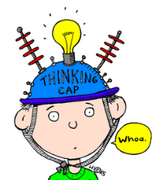


Chat Questions from Online Session 1

1. Your next patient is a parent with a 6-week-old baby. You diagnosed a moderate hearing loss last week and they are back for further discussion and a hearing aid evaluation.
  - Mom is there because she knows she should follow up but she wants this all to go away.
  - How will you help her understand the hearing loss and what it means to bonding with her baby?
  - What tools/strategies could you use to make the case for hearing aids NOW?
What can you share with her that she can bring home to her husband and extended family so she can explain the hearing loss to them? Focus on key points.

2. Word discrimination testing is very routine for audiologists, yet what it tells us about how well a person will be able to perceive speech is much more valuable than the audiogram.
One of your patients will be going to a new school to start 1st grade. He has a 35-65dB loss bilaterally and is a good hearing aid user. His WDS in quiet is 84% and in noise is 72%. What would you write in the report to the school that would help them understand this is a concern?

3. Hearing loss is not being identified because early childhood and/or school hearing screening practices are not in place, or are not effective. You are a new community audiologist. You want to truly serve the hearing needs of your community and also increase referrals. You know what hearing screening practices are recommended and why it is important. How could you go about finding out about the current state of child hearing screening in your area? This is a systems issue and rarely a single person issue. What challenges might you face? What could you do to initiate systems changes?

