Words, words, words: Civil War Re-enactment
Target Vocabulary:
canvas portable tripod musket orders
Language & Learning Concepts:
- Use photographs to visualize vocabulary words.
- Compare and contrast descriptive words and prepositional phrases.
- Use appropriate word choice to complete a sentence.
- Use context clues to define a word.

Life of a Civil War Soldier
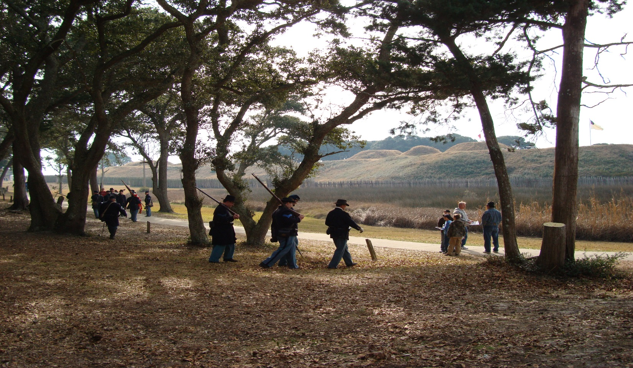
In 1861, the United States fought a war called The American Civil War. Soldiers from the North were in the Union Army. Soldiers from the South were in the Confederate Army. Union soldiers wore blue uniforms. Confederate soldiers wore gray uniforms.
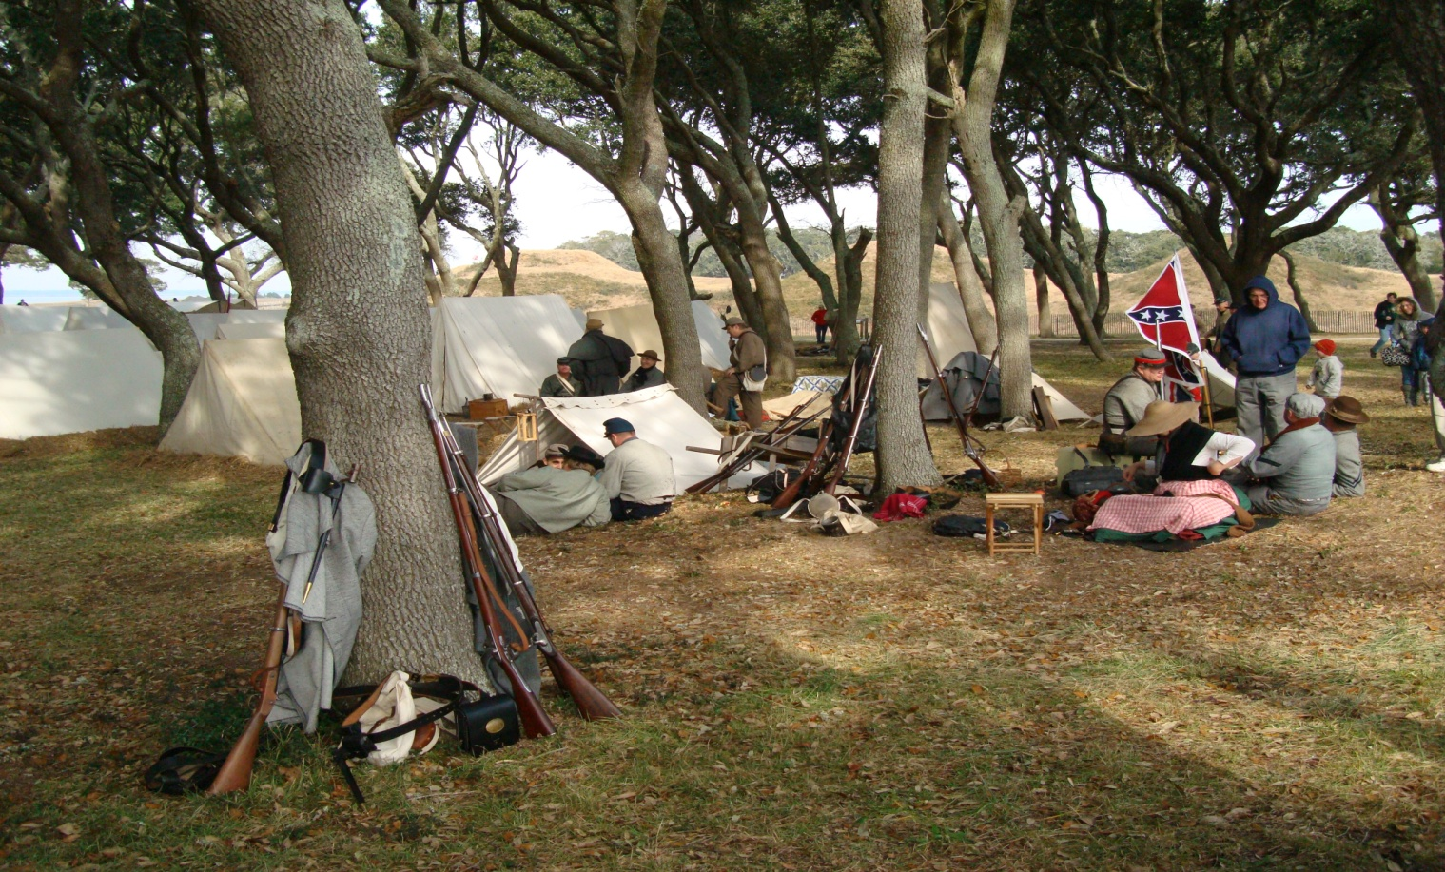
Life for soldiers is not easy.
The soldiers sleep in tents. The tents are made of canvas. Canvas is a strong fabric. Wooden poles hold up the canvas. Ropes tie the tents to the ground. When it is time to leave, the soldier will roll up the tent and carry it on his back to the new camp. Tents are portable.
- The tents are _________. large medium small
- The tents are _________. light heavy
- The tents are _________. comfortable uncomfortable
- The tents are ____ to carry. easy hard
- What happens when it rains?
_______________________________________________
- Is sleeping in a tent better than sleeping outside? Yes No
- Why? _______________________________________
- In today’s army, do soldiers sleep in tents? Yes No

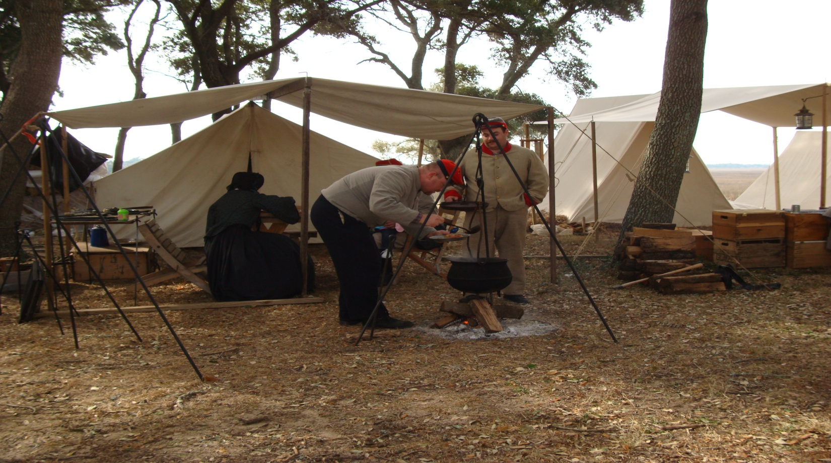
The soldiers cook over an open fire. They stir a stew in a cast iron pot. A stew is a thick soup made with meat and vegetables. It cooks for many hours. The pot is hung over the fire on a tripod. The tripod has three legs and a chain hanging from the top. The chain has a hook on the end. The pot handle hangs on the hook.
- The stew cooks _________. slowly quickly
- The tripod is set up ______. in a tent outside a tent
- The soldiers cook in _____. one pot many pots
- Are the pot and tripod portable? Yes No
- Which is better for cooking? an open fire a stove
- Why? ____________________________________________
- Where did the meat for the stew come from?
________________________________________________
- In today’s army, do the soldiers cook over an open fire? Yes No

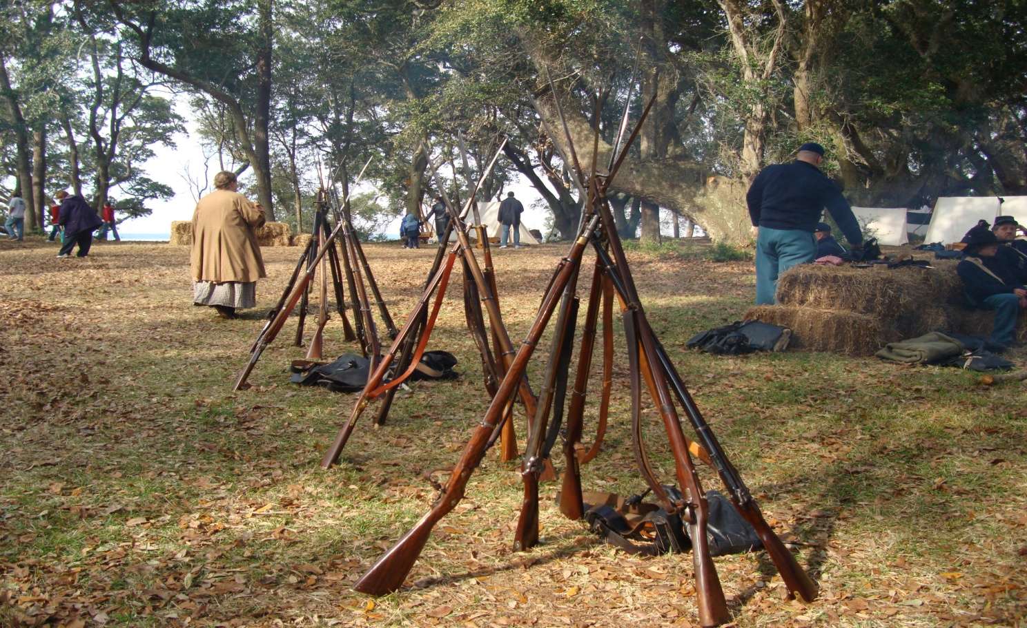

The soldiers use a gun called a musket to fight. The musket can shoot a small ball of lead. The muskets stand together like a tripod. The stand of guns keeps them off the ground and easy to find. A soldier can quickly grab a gun if someone comes into the camp.

- A musket is _________. short long
- The stand of guns keeps them ______. clean dirty
- Are the guns portable? Yes No
- Should the guns be near the cook area? Yes No
- Why? _____________________________________________
- What is in the bags by the guns?
__________________________________________________
- In today’s army, do soldiers use muskets? Yes No

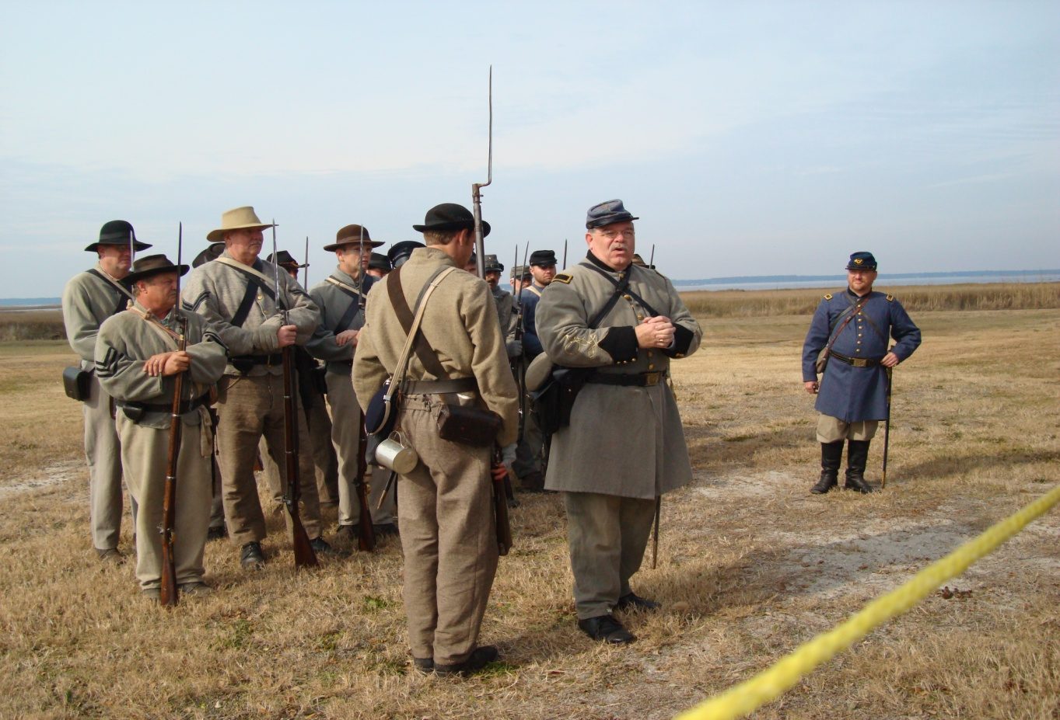

The soldiers march in a group to practice working together. The soldiers follow orders. Orders are what the leader tells the soldiers to do. Each soldier must stay with his group.

- Soldiers march ________. alone in a group
- Orders come from______. a leader a soldier
- Each soldier is in a group. Yes No
- In today’s army, do soldiers work in a group? Yes No

Tell how a soldier of the American Civil War is different from a soldier from today’s army. __________________________________________
__________________________________________________________
__________________________________________________________

