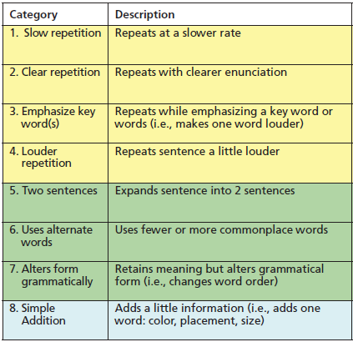
Practice Scoring – 6 year old
Huh | What | I don’t understand
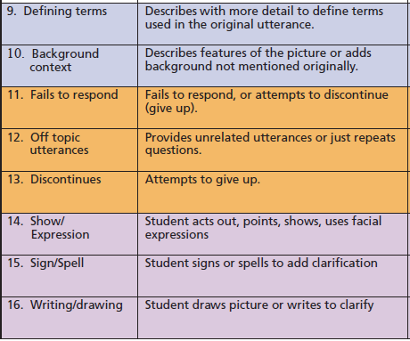
1. Original sentence: There’s a black police car, there’s a white car an orange truck, a blue car and a red car.

2. Original sentence: There’s a toothbrush with blue and black. There’s toothpaste with blue green white and purple. There’s a book with white inside and there’s soap and there’s a comb with gray and black.

