Transition Planning for Adulthood
There are many different resources available to assist families, students and school teams identify and work on next steps of readiness for post-high school goals. Basic information is included below along with examples of resources.

IDEA and Transition Planning

Preparing children with disabilities to “lead productive and independent adult lives, to the maximum extent possible” is one of IDEA’s stated objectives. [20 U.S.C. 1400(c)(5)(A)(ii)]. IDEA’s requirement for transition statements in the IEP read as follows: (b) Transition services. Beginning not later than the first IEP to be in effect when the child turns 16, or younger if determined appropriate by the IEP Team, and updated annually, thereafter, the IEP must include—
(1) Appropriate measurable postsecondary goals based upon age appropriate transition assessments related to training, education, employment, and, where appropriate, independent living skills; and
(2) The transition services (including courses of study) needed to assist the child in reaching those goals. [§300.320(b)]
This means that the IEP team must develop measurable goals for the student that are focused on the postsecondary world and specify what transition services are needed to help the student reach those goals.

Transition Skills Guidelines

Skills needed to be successful after high school include knowledge-based skills and ‘soft’ getting along with people skills. It is strongly suggested that this hierarchy be considered when developing IEP goals throughout school age. Developed in 2006 by Laurent Clerc Center National Deaf Education Center K-12 Program at Gallaudet University, the Transition Skills Guidelines provide a hierarchy of explicit skills for 8 groups: Grades: K, 1-3, 4-5, 6-8, 9, 10, 11, 12. These skills can be individualized for students with hearing loss of all different communication modalities and with co-existing learning challenges.

Standard 1: Student demonstrates the skills necessary to advocate and empower for him/herself
- self-awareness, b) rights and responsibilities, c) advocacy/empowerment, d) interpreting,
Standard 2: Student demonstrates knowledge of educational and career exploration, preparation, and planning.
a) career exploration and planning, b) career materials preparation, c) educational planning, d) learning/study skills, e) life-role planning
Standard 3: Student develops positive and practical work habits, skills, and attitudes within a work environment.
- Pragmatics/social courtesies, b) conflict resolution, c) teamwork, d) work attitudes, e) work habits, f) time management, g) resource management, h) workplace communication, i) feedback, j) performance and self-assessment, k) self-management, l) technology and equipment
Standard 4: Student demonstrates the knowledge and skills necessary to live independently and successfully.
- Emergency and environmental safety, b) personal safety, c) money/banking, d) purchasing/negotiating, e) nutrition, f) clothing, g) hygiene
Standard 5: Student demonstrates knowledge of one’s community, one’s role in the community, and available resources.
- Travel, b) community roles and responsibilities, c) leisure, d) community resources, e) community service
Click here for the full Transition Skills Guidelines 14-page planning chart.

Building Transition Knowledge:
The second edition of Self-Advocacy for Students who are Deaf or Hard of Hearing is a 2012 e-version written by Kristina English, PhD, of the University of Akron who has generously made it freely available. The materials in this workbook consist of 12 lessons, organized into four units with three evaluations and a summative learning activity. You can open each lesson individually by clicking on the Lesson link.
Unit 1: Introduction – What Is Self-Advocacy?
Lesson 1 Self-Advocacy: What Is It and Why Is It Important?
Unit 2: Knowledge Is My Power Base
Lesson 2 My Legal Rights While in High School: My IEP
Lesson 3 My Legal Rights When I Leave High School: Section 504 and College
Lesson 4 My Legal Rights When I Leave High School: ADA and Work
Lesson 5 Transitioning: Making the Move from High School to College and Work
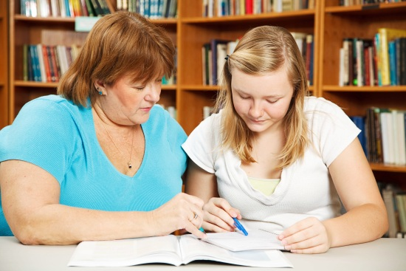
Unit 3: Personal and lnterpersonal Skills for the Self-Advocate
Lesson 6Setting Goals, Identifying Needs
Lesson 7 Expressing My Needs Effectively
Lesson 8 Negotiating with Others
Lesson 9 Resolving Problems
Unit 4: Putting It All Together: Using Knowledge with Skills
Lesson 10 My Role in Transition Planning: Preparation
Lesson 11 Practicing for an IEP Meeting: Participation
Lesson 12 Evaluating My IEP Participation

Planning for the Future - Resources
- Youthood’s Job Center: Learning About Work provides an interest exploration guide, skills profiler, transferable skills survey and job search guide with how to write a resume`
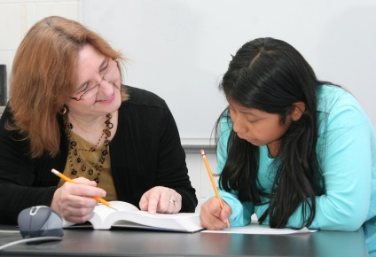
- The Planning for the future workbook is designed to help students, their families, and professionals to plan for life after high school. It uses a person-centered approach to identify student strengths and uses a problem-solving approach to develop a plan of action and a vision for the future.
- The Guide for Access Planning (GAP) has a wide variety of checklists, planners, information and activities such as different scenarios for discussion of how to improve or advocate for improved access in different situations.
- The Occupational Outlook Handbook specifies the training and education needed, earnings, expected job prospects, what workers do on the job, working conditions, job search tips, links to information about the job marked and more.
- My Road: A College and Career Planning provides a wealth of information such as free personality assessments, matching careers based on assessment results, information on colleges, majors, interviews, tips for applying to college and much more.
Resources
http://www.dhhtexastransition.org/
http://www.pepnet.org/resources/deaf
http://www.youthhood.org/jobcenter/lw_index.asp
http://transitioncoalition.org/transition/tcfiles/files/docs/planning_future1213214588.pdf/planning_fut
http://www.phonakonline.com/MyGap/GapMain.html
http://www.bls.gov/ooh/
https://myroad.collegeboard.com/myroad/navigator.jsp
http://nichcy.org/schoolage/iep/iepcontents/transition
http://www.gallaudet.edu/documents/clerc/TSG.pdf

