Student Teacher Gr
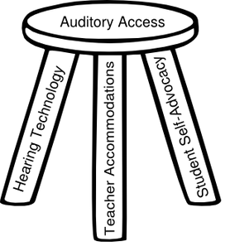
Itinerant Teacher of the Deaf/Hard of Hearing Date
NECESSARY SUPPORTS WORKSHEET
This student has an educationally significant hearing loss in the R / L ear. In order to fully participate and communicate as effectively as students without hearing loss, hearing technology, classroom accommodations and specific skill building is typically needed.
Issue | Example of skills we will be working on: | Once learned, he will be able to:

IDEA Sec. 300.113. (a) Each public agency must ensure that hearing aids worn in school by children with hearing impairments, including deafness, are functioning properly. (b) (1) Each public agency must ensure that the external components of surgically implanted medical devices are functioning properly. Data verifying technology function should be available if the district is monitored for IDEA compliance.
Under the Title II ADA Policy Clarification (Nov. 14, 2014) schools have the responsibility for ensuring that communication access is as effective for children with hearing loss as their typical peers and requires that schools must provide appropriate auxiliary aids and services so that students with hearing loss have an equal opportunity to participate in, and enjoy the benefits of, the services, programs, and activities of the public school district. This applies to ALL students with known hearing loss, not just those with IEPs or 504 plans.
Issue | Classroom Accommodations

2015 © Karen L. Anderson, PhD, Supporting Success for Children with Hearing Loss. http://successforkidswithhearingloss.com Consent is used for this material to be used to benefit students with hearing loss.

