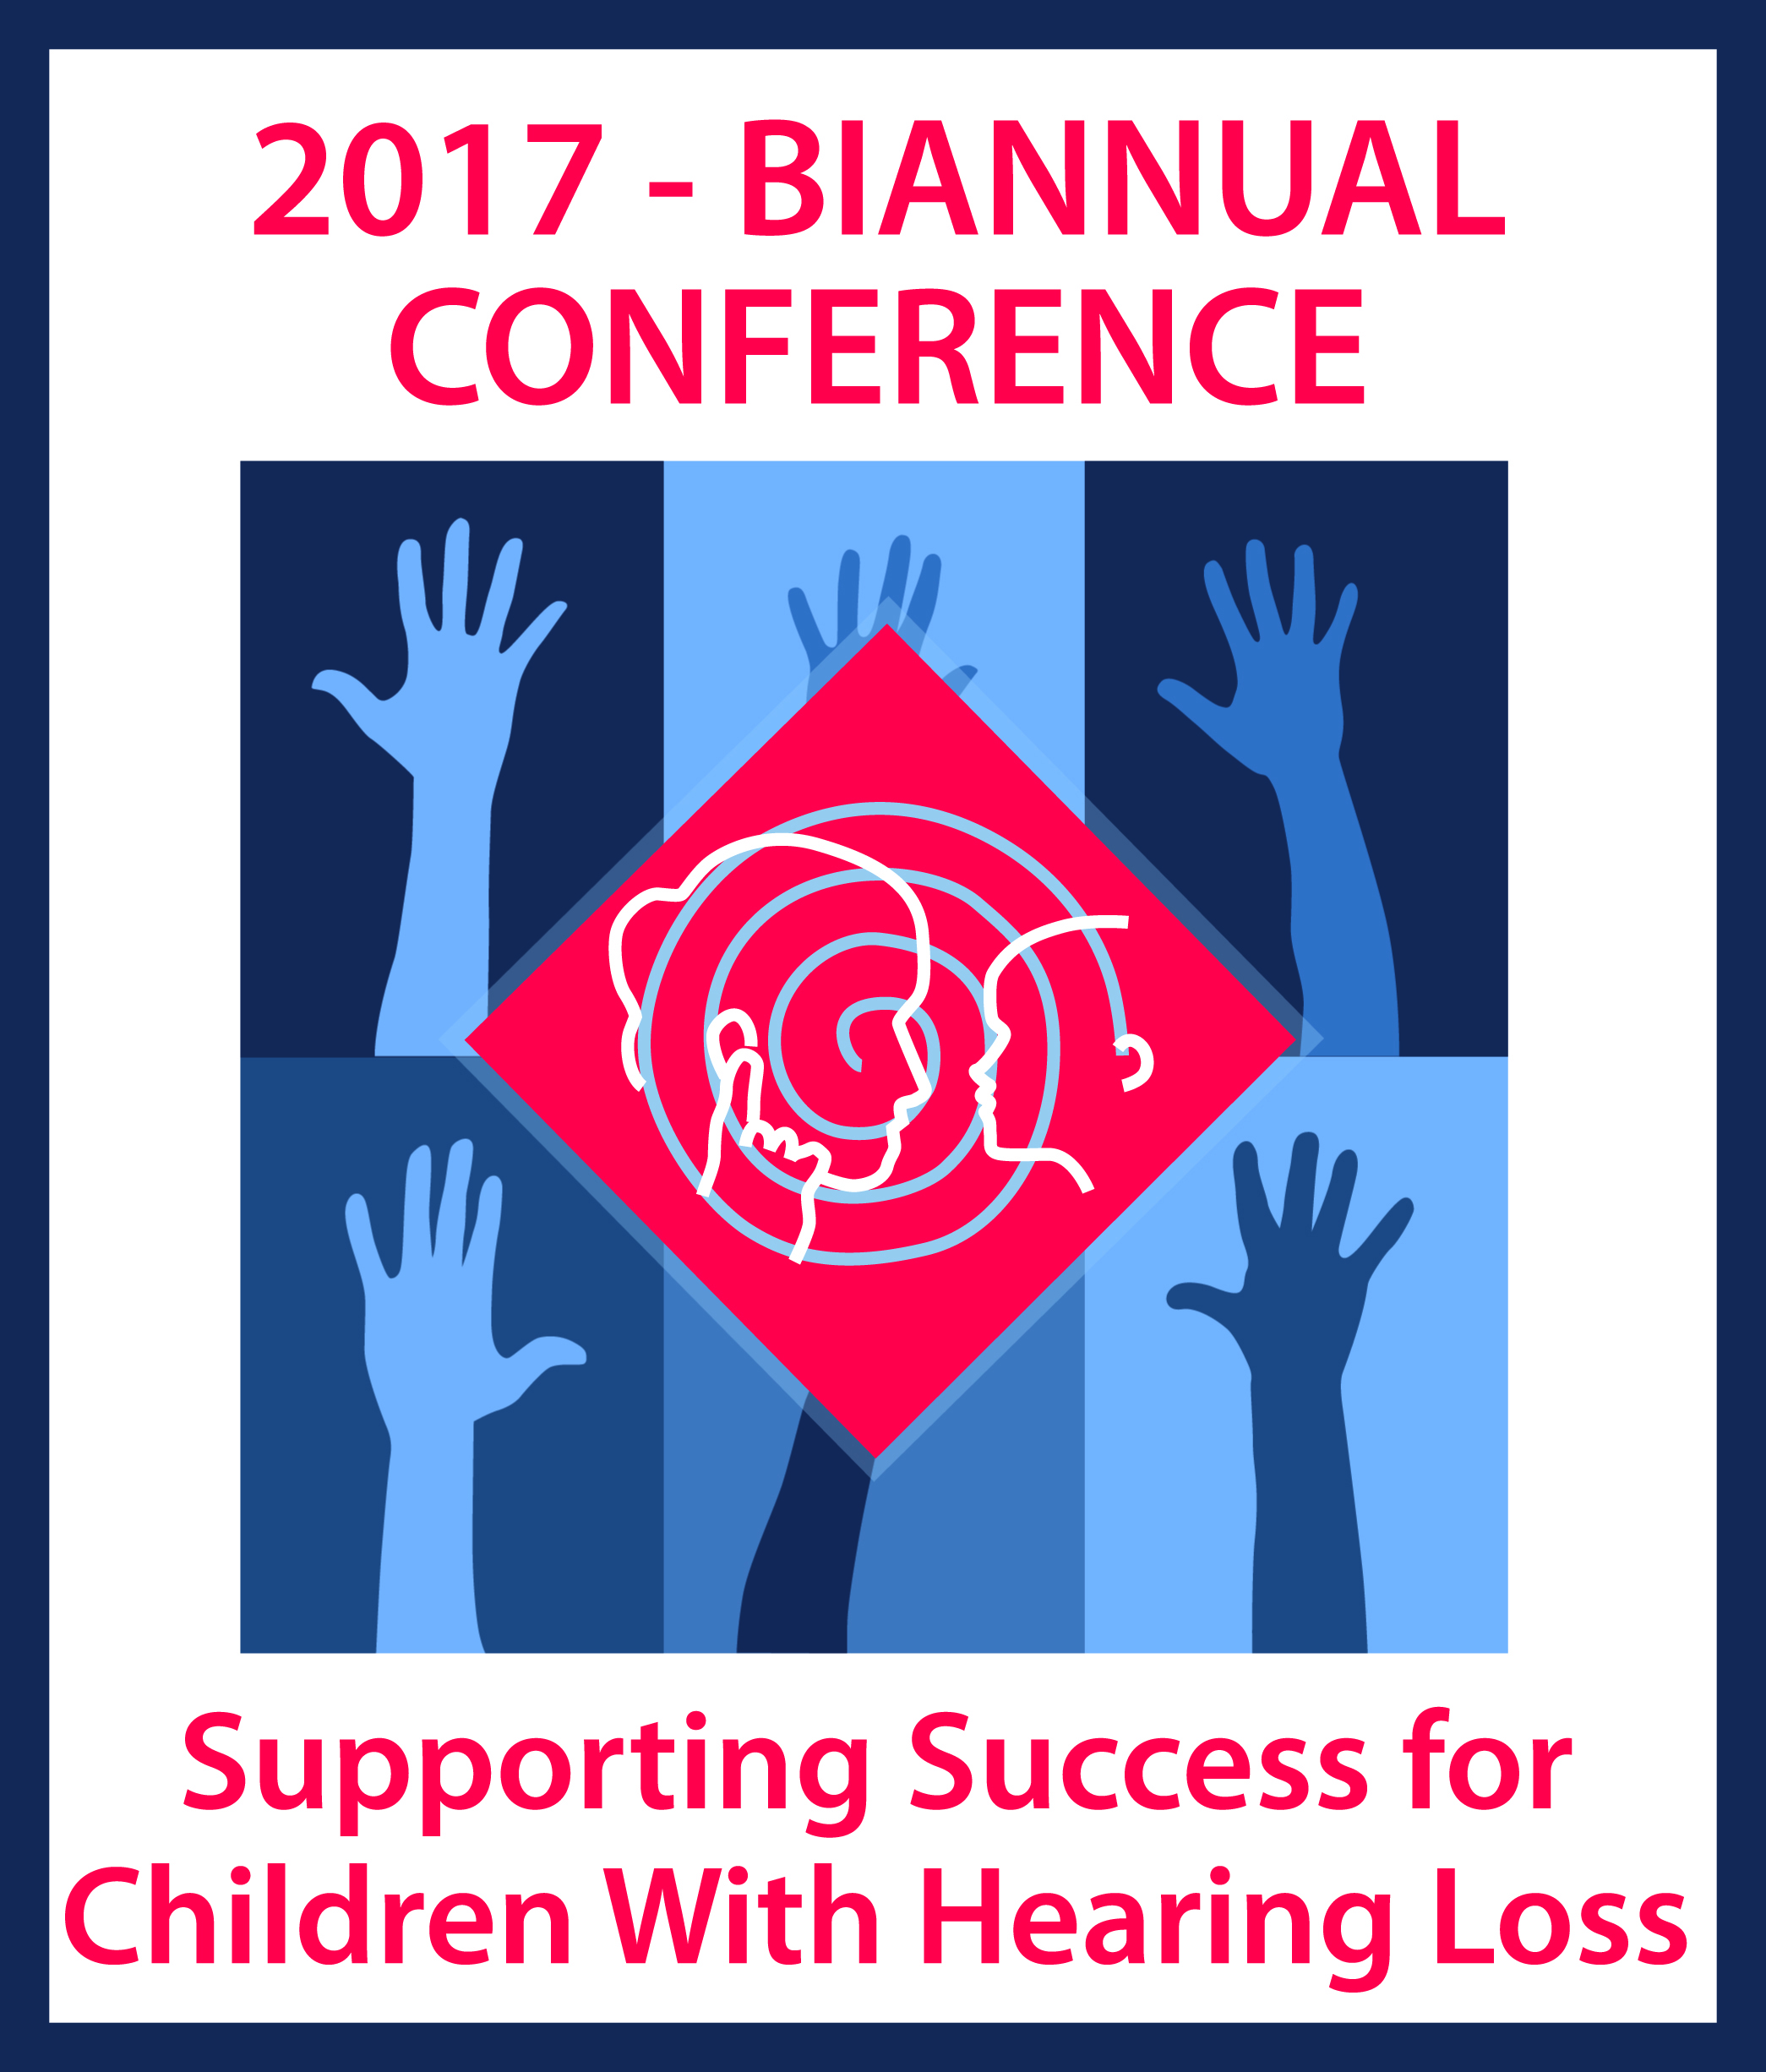

Conference Registration Information
Required for Payers via Purchase Order

Thank you for your interest in attending the 2017 Supporting Success for Children with Hearing Loss Conference! We require the following information for all registrants. If your purchase order is for multiple individuals, each person will need to supply the following information. Please copy this form, have it completed by all registrants and provide it with your PO (fax: 480-393-4331). Alternately you can scan and email the PO/form(s) to accounting@successforkidswithhearingloss.com.
Put an X in front of your registration:
Preconf only 1 (PrSch) | Preconf only 2 (Sch)
Preconf 1 + Friday | Preconf 2 + Friday
Preconf 1 + Fri + Sat | Preconf 2 + Fri + Sat
Friday only | Friday + Saturday

Registrant Information

First Name:
Last Name:
Email Address:
What group are you in? (select one or more with an X before the group name)
Teacher of the Deaf/Hard of Hearing
Audiologist
Speech/Language Pathologist
Administrator
Student (University)
Parent/Family Member
Other:
How long have you been in the field of supporting children with hearing loss?
0 (University student)
1-5 years
6-10 years
11-15 years
15+ years
Do you need accommodations? (REQUIRED ANSWER)
No accommodations needed
ASL interpreter
FM receiver (provided by Oticon)
Captioning (will be streamed to a device that you provide)
Do you have any dietary restrictions?
No diet restrictions
Gluten-free
Vegan
Vegetarian

