Door Prizes for 2015 SSCHL Conference
- Weird
- F is for Feelings
- Eggbert
- What Works for Me
- Exploring Careers
- Summer Jobs & Beyond
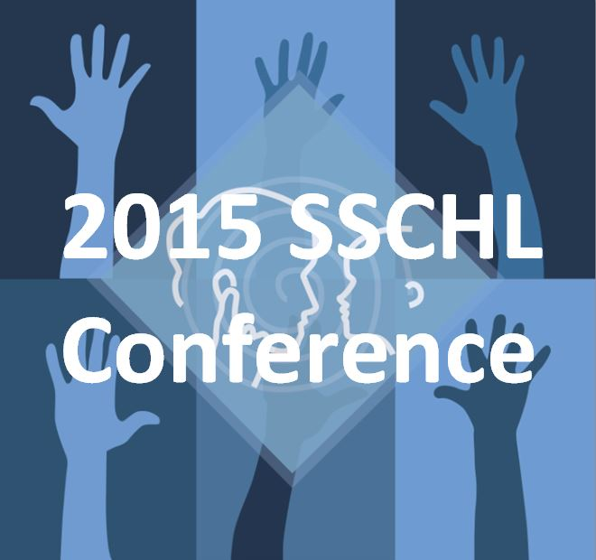
- 3 FLE CDs
- 3 LIFE-R CDs
- 2 Teacher Tools 2014-2015 CDs
- 5 Ways to Say Good Day DVD
- Understanding Math Story Problems
- Common Objects Test (COT)
- TesTrax speech tracking CD
- SPICE Curriculum
- TalkAbility
- 10 sets of free Ear Gear!
- Children with Audiological Needs (thanks to Butte)
- Advocacy in Action (thanks to Butte)
- 3 Simulated Hearing Loss CDs
- Oliver Gets Hearing Aids Literacy Booster CD
- Oliver Gets FM Literacy Booster CD
- Sophie’s Tales Listening to Learn
- Sophie’s Tales Overcoming Obstacles
- SCRIPT DVD
- Rule the School Self-Advocacy Game
- Phrases in ASL
- 25 SSCHL mugs with treats

