April 9, 2012

Dear Families of Children with Hearing Loss,

We are pediatric audiologists who are very concerned about the challenges that families have in keeping hearing aids on their young children. It can be very trying to keep hearing devices on the heads of active young children! Recent research has indicated that MOST families do not achieve full-time hearing aid wear by school entry. Many families have been frustrated at how to keep their child’s hearing aids on and through much effort have found what worked and what did not work for their family.

We are beginning a research project that will consider different retention/protection/safety options and strategies that families could use to help them keep their children's hearing aids safer from loss and/or improve retention. As part of this project, we are collecting information from families and from pediatric audiologists about what has worked for them in helping to keep hearing technology on children. This information will be included as we develop materials to provide to audiologists and families about specific strategies to assist in keeping technology on children.

The end result will be a brochure for families to help them understand strategies and what devices are available to help keep technology on. The goal is that a higher proportion of children will achieve full-time hearing technology wear at an early age. This one change could result in reducing millions spent in educational support, improve resulting vocational potential and result in increased life-long independence of individuals with hearing loss.

Please help us by completing the family survey at
https://www.surveymonkey.com/s/MPXZMF3

We would also be grateful if you could ask your child’s pediatric audiologist to complete the audiology survey at
https://www.surveymonkey.com/s/MPLXDBK

Thank you in advance for your thoughtful assistance towards improving the futures of children with hearing loss.

Sincerely,

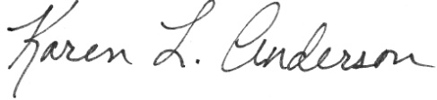

Karen L. Anderson, PhD, CCC-A, ABA Jane R. Madell, PhD, CCC A/SLP, LSLS Cert AVT
http://successforkidswithhearingloss.com www.JaneMadell.com

