April 9, 2012

Dear Audiology Colleagues,

As pediatric audiologists, we are very concerned about the challenges that families have in keeping hearing aids on their young children. Recent research has indicated that MOST families do not achieve full-time hearing aid wear by school entry.

We are beginning a research project that will consider different retention/protection/safety options and strategies that families could use to help them keep their children's hearing aids safer from loss and/or improve retention.

We are collecting information that will be used to develop materials to provide to audiologists and families about specific strategies to assist in keeping technology on children. The goal is that a higher proportion of children will achieve full-time technology wear at an early age. This one change could make the job of pediatric audiologists easier and result in reducing millions spent in educational support, improve resulting vocational potential and result in increased life-long independence of individuals with hearing loss.

As part of this project, we are collecting information from audiologists and from families about what has worked for them in helping to keep technology on. The end result will be a brochure for families to help them understand what devices are available to help keep technology on.

Please help us by completing the audiologist’s survey at https://www.surveymonkey.com/s/MPLXDBK

If you submit your email at the end of the survey, you will receive a summary of the information when the project has been completed.

We would also be grateful if you could ask families to complete the family survey at
https://www.surveymonkey.com/s/MPXZMF3

Thank you in advance for your thoughtful assistance towards improving the futures of children with hearing loss.

Sincerely,

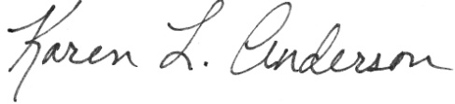

Karen L. Anderson, PhD, CCC-A, ABA Jane R. Madell, PhD, CCC A/SLP, LSLS Cert AVT
http://successforkidswithhearingloss.com www.JaneMadell.com

