Ear Infections and Early Learning

So what are ear infections?
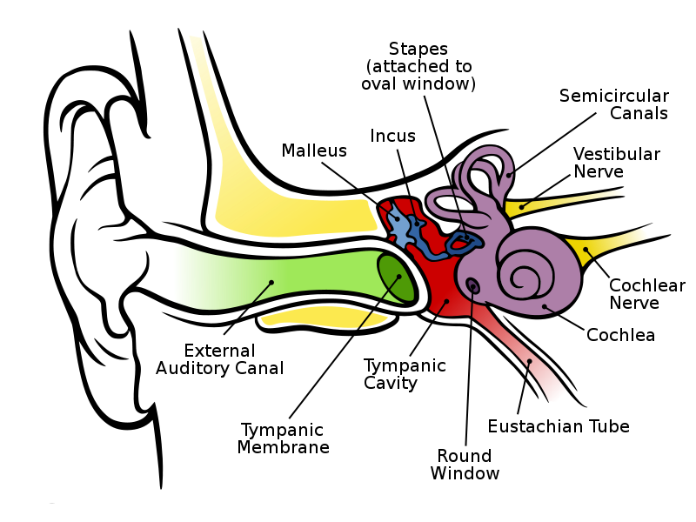
Fluid can develop in the middle ear space behind the eardrum because of Eustachian tube dysfunction – or ears that don’t “pop” often enough. On the chart below, the eardrum is shown as the dark green oval. The middle ear is the red space on the right side of the eardrum. The Eustachian tube is shown as the red channel pointing downward. It connects to the back of the throat. The Eustachian tube points more sideways than downward in babies and young children which makes it easier to close off when the throat is swollen from a cold, allergies, or even teething. Think about having ears that feel “stuffy” when you have a cold. This happens because air pressure is building up in your middle ear space because the Eustachian tube is not opening as often as it usually does. The pressure actually pulls your eardrum inward causing a stretchy or full feeling. If the tube does not open for many hours, the vacuum can build up to the point where clear fluid is pulled from the tissues of the middle ear. A child may stop fussing when the pressure is relieved by the middle ear filling up with fluid and the eardrum no longer being stretched inward. This is called otitis media with effusion (ear-middle-fluid). When fluid collects behind the eardrum because the Eustachian tube is blocked, it may or may not become infected. Ear infections can happen after a child has had a cold because germs can travel up the Eustachian tube and cause an infection in the middle ear space. This is called acute otitis media. Ear infections typically last 2-3 weeks. They cause no pain in almost half of the cases, but the child may only be cranky, sleepless or have a fever.

Don’t all children have ear infections?
Almost! About 90% of children have experienced fluid or infection behind their eardrums between the ages of 6 months to 4 years. Half or more of preschoolers have middle ear fluid or infection some time during the year. Young children growing up in households with smoke present (cigarettes, woodstove), those that were not breastfed and those attending large child care centers were more likely to experience repeated ear fluid or infections. At least ¼ of the time parents are not aware that children have fluid or infection behind their eardrums. Ear infections or fluid behind the eardrum usually clears up by itself within 3 months without needing any medicine. This is why many doctors take a “wait and see” approach rather than prescribing medicine for an ear infection on the first visit. About 10% of children who get ear infections or fluid do not get better within 3 months. This group may often have one ear problem after another, sometimes for many months or years. This is called chronic or recurrent otitis media. Longterm ear infections, if untreated, can have serious health and education consequences.

When do children outgrow ear infections?
Not all children outgrow ear fluid or infection problems by the time they enter school. One out of every 4-5 children in the early elementary school years continues to have ear infections or fluid behind the eardrum. A smaller number of children continue to have ear problems into adulthood. A higher number of children receiving specialized instruction services also have ongoing middle ear problems than children who do not have learning problems.

Ear infections cause how much hearing loss?
People with hearing loss can typically detect sound at a 0 dB hearing level. The presence of middle ear fluid or infection behind the eardrum causes some blockage to sound. Some children may have 10-15 dB hearing loss. Other children may have up to 50 dB of hearing loss. When you plug your ears with your fingers you give yourself about a 20 dB hearing loss. People talking at a normal conversational loudness usually talk at about 45 dB, so having 50 dB of hearing loss would mean that only speech that was loud or very close to the child would be heard. Children with long histories of ear problems that do not resolve on their own are likely to have more hearing loss than children with a few ear problems that did clear up on their own or after one period of taking medicine.
How does a history of ear infections affect early learning?
If you listen for a little while with your ears plugged with your fingers you will notice that it is harder to catch all of the words that people say, more difficult to pay attention and it may be easy to become distracted because it takes more effort to hear and understand. Similarly, children who have had many ear problems may show the following:
- Not following directions
- Asking you to repeat what you said
- Seems to be ignoring you
- Does not seem to pay attention to sounds or speech most children would be interested in
- Sometimes their speech can be more unclear than is typical for their age
Some studies have shown a link between recurrent ear infections and speech, language, reading and attention problems. One study found that 75% of children who had gifted characteristics who did not score in the gifted intelligence range had long histories of middle ear problems. More recent studies have shown that most children with hearing loss that comes and goes from recurring middle ear fluid that did have early attention or language delays by age 3 usually did not have measurable learning differences by the time they were in second grade. However, children who did spend their early years with inconsistent hearing do have more difficulty understanding speech when there is background noise. This can be a true disadvantage in schools with noisy, active classrooms. What seems to also be true is that a history of many middle ear problems, when added to another learning problem will result in making the learning problem worse when compared with children with a variety of problems who did not also have ear problem histories. Irregular medical care to treat middle ear fluid or infections also causes a child to be at higher risk for learning issues. Certainly, a child who usually has hearing loss greater than a plugged ear level (25-50 dB HL) will be more likely to be behind in language and reading skills and have attention issues.

What can I do?
- Seek medical help. Your child’s doctor needs to be aware that he or she is having an ear problem before it can be treated. “Watchful waiting” or observing to see if an ear problem clears up on its own starts on the first visit and may go for 3 months. If you believe that your child has ear infection, fluid behind the eardrum and hearing loss, the longer you wait to seek medical help the more you will be delaying the watchful waiting process.
- Stay close. Think about what it’s like to listen with a plugged ear loss and what helps. Get close to your child before you tell him something important. If you want him to follow a direction be sure to be within arm’s reach (no more than about 4 feet) when you give the direction. Get his attention before you talk to him if you really want him to understand you. When the television or music is on in the background your child will have much more difficulty knowing when you talk and what you say.
- Be patient. There may be times when your child seems to be ignoring you or willfully not doing what you say. It may be because he did not hear you or only heard part of what you said.
- Spend time on language and literacy. It is likely that your child missed out on many language experiences when he was not hearing his best. Take time every day for quiet conversation to talk about what interests the child and reading books with him.
- Advocate for your child’s needs. Teachers who are aware that a child has many ear infections and inconsistent hearing are usually happy to seat them close to the front of the classroom. The school nurse is also a resource and may be able to check your child’s hearing if you or his teacher thinks that it may have changed. If your child seems to be having learning difficulties, be sure to remind the school staff of his history of inconsistent hearing and be open to them evaluate the child to see if special help or accommodations are needed.

Related Information
- Ear Infections and Language Development: US Department of Education & American Speech and Hearing Association
http://www2.ed.gov/offices/OERI/ECI/earinfections.pdf
- Hearing Loss and its Implications for Learning and Communication: American Speech and Hearing Association
http://www.asha.org/uploadedFiles/aud/InfoSeriesHearingLoss.pdf
- Middle Ear Infection & Surgery: KidsHealth.org
http://kidshealth.org/parent/medical/ears/ear_infections.html?tracking=P_RelatedArticle
- Ear Infections in Children: New York State Department of Health
http://www.health.state.ny.us/nysdoh/antibiotic/4815.pdf
- Ear Infections: The Parent Report
http://www.theparentreport.com/resources/ages/infant/health/203.html

Developed by Karen L. Anderson, PhD for the Minnesota Department of Education Parents Know website, 2011 (http://parentsknow.state.mn.us ).

